**ITU Centres of Excellence Network for Asia and the Pacific**

**State Radio Monitoring Center - China**

**Training on**

**Monitoring RF Spectrum in modern wireless era**

**Kunming, Yunnan Province, China (People’s Republic of)**

16– 20 April 2018

Practical Information for Participants

# INTRODUCTION

The International Telecommunication Union (ITU) and the State Radio Monitoring Centre (SRMC), MIIT, China are organizing the ITU ASP CoE Training on Monitoring RF Spectrum in modern wireless era, from 16 to 20 Apr. 2018 in Kunming, Yunnan Province, China.

This document provides some practical information on frequently asked questions about the events, including logistical details.

# Venue

The events will take place at the Holiday Inn Kunming City Centre, Kunming, Yunnan Province.

The contact details of the venue are as follows:

Venue: Holiday Inn Kunming City Centre, Kunming, Yunnan Province.

Address: No.29 DongFeng East Road, Kunming, Yunnan Province, 650011 P.R. China.

# TRANSPORTATION

# From Kunming Changshui International Airport to the hotel

SRMC will provide airport pick-up service. In order for us to make further arrangements for your stay, please inform us of your arrival/departure date and flight number.

If you want to get there by yourself, subway is available and convenient. Take subway Line 6 at the airport station, then transfer to subway Line 3 at the East Bus Station and get off at Dongfeng Square Station, at last walk for a few minutes you will reach the hotel.

# Hotels

The Holiday Inn Kunming City Centre is four-star hotel with convenient public transport. It is adjacent to Kunming metro line 3(DongFeng Square Station), 5 minutes driving from the hotel to Kunming Railway Station and 40 minutes to Kunming Changshui international airport.

The fee for accommodation (single room and one breakfast) is RMB450/room/night.

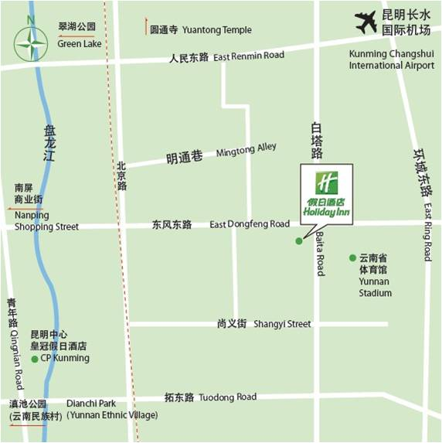

# Passport and Visa

Citizens of other countries should possess a valid passport to enter China. The passport should be valid for **at least 30 days** after arrival date in China.

Citizens of some countries are required to obtain a visa in order to enter and stay in China. The visa must be requested and obtained from the Chinese Embassy/consulate in your country, or if there is no such office in your country, from the one that is closest to the country of departure.

In order to get the invitation letter for the VISA, please forward the registration confirmation email and send the copy of your passport to Ms. Wang Zhixia ([office@srrc.org.cn](mailto:office@srrc.org.cn)) with a copy to **Mr. Aamir Riaz** ([aamir.riaz@itu.int](mailto:aamir.riaz@itu.int)) before **15th of March 2018 the latest.**

# About China

The People's Republic of China is a socialist country with its own characteristics. China is a developing country and lies in the east of Asia. It is bordered by Russia and Mongolia to the north and North Korea to the northeast. To the south, its neighbors are Vietnam, Laos, Thailand and the Philippine. To the west and southwest India, Burma, Bhutan, Nepal and Pakistan. To the east Japan, which faces China across the East China Sea.

China is a vast territory of over 9,600,000 square kilometers. It has a population of more than 1.3 billion, which is a quarter of the world population. It consists of 34 provinces, autonomous regions, and municipalities directly under the Central Government. Beijing, which is situated in the Northeast of China, is the capital.

China is characterized by a continental climate. The latitude spans nearly 50 degrees. The greater part of the Chinese territory is situated in the Temperate Zone, its southern part in the tropical and subtropical zones, and its northern part near the Frigid Zone. Temperatures differ therefore rather strikingly across the country. The northern part of Heilongjiang Province has long winters but no summers; while the Hainan Island has long summers but no winters.

The People's Republic of China was founded on October 1, 1949. Today, China is implementing reform and opening-up policies, and has established socialist market economy, thereby charting the course for socialist modernization with Chinese characteristics.

Language and Character Chinese is commonly used in modern China. It is one of the six working languages designated by the United Nations and, as a written language; Chinese has been used for 6,000 years.

# About Kunming

Kunming, the Capital of Yunnan Province, located at an elevation of 1,950 meters on the Yungui Plateau with low latitude and high elevation, has one of the mildest climates in China. Controlled by a subtropical highland climate, the annual temperature of Kunming is of no drastic change with the average daily temperature of 15.1 degree Celsius. With its perpetual spring-like weather which provides the ideal climate for plants and flowers, Kunming enjoys the reputation of "Spring City" and attracts thousands of the red beak seagulls from Siberia every winter.

With the superior geographical advantages, Kunming is China's gateway to Southeast Asia and South Asia ,and the land hubs for economic, trade and political ties between East Asia and the Indochina Peninsula. According to the 2012 Public Appraisal for Best Chinese Cities for Investment ,Kunming was chosen as one of the top fifty cities to invest in China. And it has a long history with a splendid culture and ranks one of the 24 famous historical and cultural cities in China. There are 25 minorities inhabited in this area and the folk customs are pretty colorful. Ethnic Festival, such as Toech Festival , Water-splashing Festival, Double-Third Festival and Munao Festival are so brilliant as to enchant people. The favorable natural climate conditions, unique natural and human landscapes, fascinating ethnic customs and abundant natural resource make Kunming even more miraculous and beautiful, and it was named China's 2th -most livable city in 2016.

As one of the top ten tourist hot spots of china, there are more than 200 cultural relics protected by the government in the city, such as Shilin Geopark, Dianchi Lake, Anning Hot Spring, Sedan Snow Mountain, as well as World Horticultural Exposition Garden and Yunnan Nationalities Village more than 100 key scenic spots. Kunming's cuisine such as wild mushroom is distinctly Yunnanese and combines fresh ingredients afforded by the moderate climate with mild herbs and spices giving its cooked dishes sufficient flavour. And Kunming is also rich in the delicate Guangdong Cuisine, various kinds of fashionable foreign delicacies, and popular Sichuan Cuisine such as the hot pot.

# Transportation

**Public Transportation in Kunming consists of: subway, buses and taxi.**

# Health Care

### Pharmacy and good medical facilities are largely available in Kunming. Emergency medical services: 120

# Useful Emergency Numbers

### Police: 110

### Fire Brigade: 119

# Language

Chinese is the official language in China, but English is widely understood in major hotels, restaurants, banks and businesses. The training will be held in English.

# Currency and Banking

The official currency accepted in China is RMB. Major foreign currencies April be exchanged to RMB at banks. Official banking hours can vary slightly, but in general are from 9:00 a.m. to 17:00 p.m. Banks are generally closed on weekends and holidays. The current exchange rate is approximately 6.3RMB to 1 US Dollar as of January 2018. Cash can be easily withdrawn 24/7 from the numerous ATMs spread in the city.

# Credit Cards

Major credit cards (American Express, Diners Club, MasterCard, VISA and UnionPay card) are accepted by most hotels, restaurants, car rental agencies, department stores, but no small local shops. Usually there is a sticker at the entrance indicating which cards are accepted.

# Climate

Temperature in April in Kunming: Average high (C/F):24/75

Average low (C/F): 10/50

The suitable for wearing windbreaker, shirt, jacket.

# Local Time

The local time is UTC/GMT +8hours.

# Tipping

Tipping is not customary in China.

# Taxes

Usually the displayed prices have sales tax included in China.

# Electrical Appliances

The standard power supply in China is 220 volts, the frequency is 50Hz. The type of power outlet/connector used in China is a two parallel outlet hole or three-hole outlet triangle. For the convenience of participants to use, we will provide wiring board, which is porous outlet.

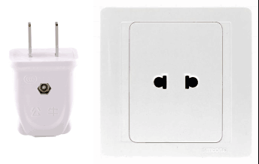 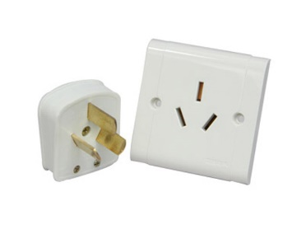 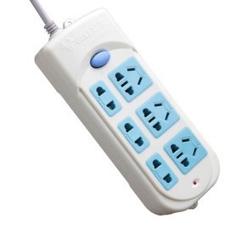

two parallel outlet hole three-hole outlet triangle wiring board

# Calling Code

The national code of China is 0086 and Kunming is 0086 871.

# Buying a local SIM

China has three operators, China Unicom, China Telecom and China Mobile. Now buy a local SIM card in China requires real-name system purchase. Foreigners bring the passport in the operator’s business hall buy the local SIM card.

# Driving

### Cars in China have their steering wheel on the left and are driven on the right of the road. For additional information, please contact the following local coordinators:

### Ms. Wang Zhixia ([office@srrc.org.cn](mailto:office@srrc.org.cn))

### Mr. Christiono Andreas (andreas.christiono@itu.int)

### Mr. Aamir Riaz ([aamir.riaz@itu.int](mailto:aamir.riaz@itu.int))

### Have a nice trip to Kunming!