

**Internet of Things**

* **Working Group Exercise**

**PLANNING INTERNET OF THINGS (IoTs) NETWORKS**

**25 – 28 September 2018**

**Bandung - Indonesia**

|  |
| --- |
| **ROSANIA**  **NORMALIA**  Portica  Paltic Sea  **ASIANIA** |

**ASIANIA (2018-2021)**

# A Country overview and the ICT environment

## 1 Country profile

### 1.1 Geography

Asiania is a middle income developing country located in Asia. The country has a varied geography with 20% of areas as mountains and difficult terrain in the north and north-west. It has an area 300 thousand square kilometers. The country has 50% fertile land, mostly in central plains and part of south. The country has only two neighbours. The relationship of Asiania with the eastern neighbor Normalia has been more competitive than collaborative. Normalia has been trying to mirror the growth story of Asiania but with limited success, largely because of bad governance. The western neighbor Rosania is a rather large country and the region bordering with Asiania is mostly deserts and mountains. Rosania’s development focus is on its western side and has very limited interest on the eastern side.

### 1.2 Demography and economy.

Population of Asiania according to the National Statistics Bureau as of December 2015 is 90 million, out of which majority of population is in the 15-50 age groups. According to the Asiania 16th Five Year Plan, the population is expected to reach 92 million persons by 2020, and will further increase to 100 million persons by 2030. During the period 2015-2030, the working age population is estimated to grow by around 25 per cent.

The Per capita GDP is USD 5500 per annum. The income is largely driven by mineral excavation and exports, tourism and construction (lately), and international trade of oil and gas. The country has a very attractive regional financial and commodities trading market. Due to recent decline in oil prices, the trade industry has taken a hit. However, the mineral industry and financial markets continue to grow.

Asiania has a very fertile land in the central region while the northern area has mountains and thick forests. The area in the west has mountains and deserts. The focus of the government since the last 20 years was on boosting the gross development product and has relied largely on its services and trade industry. The road infrastructure in the southern part of the country is very good as it serves the most important areas of business. In the central area, the transport infrastructure is moderate while it is poor in the northern area.

The telecom infrastructure is rather well developed, driven by the strong demand for business and liberalization policy of the government post the WTO agreement in 2002.

The southern part of Asiania is the services hub and hosts 40% of the population. Access to the Paltic Sea provides an excellent trade route connecting North & South America and the rest of Asia. It also has a big port in the southern city of Portica that provides trade transit for oil. The economic policy of the country has been a very liberal one and the country has developed into a formidable trading hub.

The literacy is around 92% and finance is a very attractive business leading to migration from central and northern Asiania to southern region. Technical and business education is high in demand as South Asiania is in need of high quality business and technical workforce with higher salary. The previous government that was very ICT savvy driven largely by huge license fees and high quality telecom network requirement, has set up an incubation hub (I-T Park) for information technology companies. The I-T Park is home to some of the big IT companies and they are harnessing the low salary high quality technical and financial experts to develop software solutions for trade logistics and financial companies. E-commerce is new and on the rise but there is very little awareness of e-commerce in the primary industry.

### 1.3 Government of Asiania

The government of Asiania is headed by the Prime Minister and has 10 Ministries.

|  |  |
| --- | --- |
| 1. Ministry of Agriculture, Livestock and Forests 2. Ministry of Commerce and Trade 3. Ministry of Education 4. Ministry of Finance 5. Ministry of Foreign Affairs | 1. Ministry of Home Affairs 2. Ministry of Health 3. Ministry of Information and Communication Technology 4. Ministry of Labour and Human Resources 5. Ministry of Works and Human Settlements 6. Ministry of Environment and Forests |

A newly elected government has just come into power. This party has largely been in the opposition in the last 20 years and has been very critical of the government’s lack of focus on primary industries (e.g. agriculture, logistics, transport) and the declining share of agriculture and manufacturing in the GDP composition.

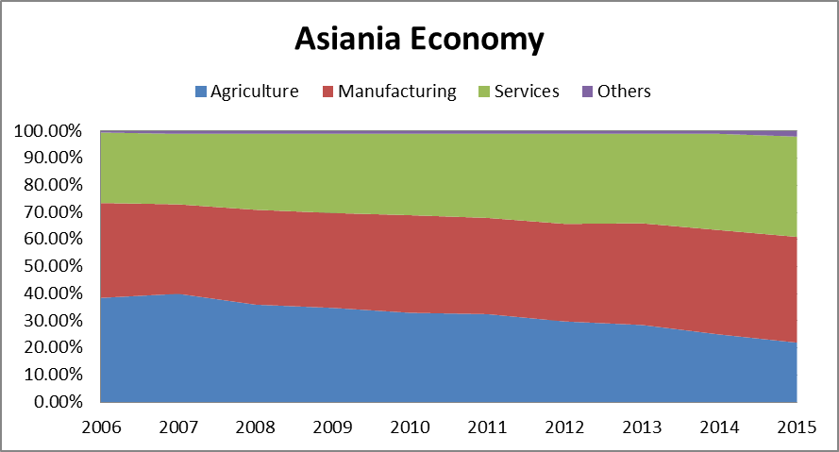

Figure 1: Composition of Asiania economy

The Prime minister firmly believes in the need for food security and development of primary industries while leveraging on ICTs. It has made development of central and northern agenda as focus area for the next 5 years. It has put in place a new Digital Society program 2030 aligned with the United Nations Sustainable Development Goals.

The focus of digital society program are on nation-wide digital infrastructure, creating knowledge based economy, boosting the all economic sectors (with focus on the primary sector), improving the environmental conditions using ICTs and developing digital skills.

### 1.4 Administrative divisions

Asiania has a democratically elected government. The country is divided into 10 Provinces and 30 districts. All districts are divided into blocks or groups of villages, the second-level administrative units that include several villages.

## 

## 2.0 ICT sector status in Asiania

## The current government of Asiania is very ICT savvy and views ICT as a core engine for socio economic growth. The telecom sector has 4 mobile operators with over 90% rural broadband coverage. The quality of mobile broadband service is very high in south and moderate nationwide. With the endeavour in last 4 years through USO fund, all the sub-district (block) headquarter in central and south have 4G LTE deployment. Where post offices are located, there is now fibre connectivity. E-government service booths are located in the Post Office premises, which is near the agriculture extension offices. The extension offices, however, have only mobile telephones with voice and low speed data. The northern area has 3G coverage. The country has 97% mobile coverage by population and around 60% by area.

Smartphone penetration (currently 30%) is on the rise largely because most of the population is young and ICT literate. The decreasing costs have made smartphones affordable for most population. Mobile apps, especially those linked with entertainment and social media is very popular though there is limited e-governance app in the market. WhattsApp and Line are the most popular social media apps being used at the moment in Asiania.

## 3. E-government status and use of ICTs by other government agencies

The Government of Asiania is very interested to roll out e-government services and wishes to do so to all citizens, even in the remote areas of the country as part of Vision 2021. At present the e-Government is coordinated by an independent entity directly under the Prime Minister’s office. These services are available in big towns and district headquarters. Some of the key citizen services have started and most importantly the process of citizen ID was completed in 2015. The government has also its own application platform and the Prime Minister’s Office is encouraging the government entities to use the platform. The mobile operators and banks have also rolled out mobile banking services in 2016.

The Department of transport and logistics (including Shipping) and tourism have evolved an e-application strategy and are pushing the local municipalities to develop smart cities around the South Asiania. The electricity department has some ongoing pilots with smart metering but has not been a priority area.

The Ministry of Environment has been very conscious of the growing challenges that cities in Asia have faced with increasing pollution and has been stressing the Prime Minister’s Office to impose strictly standards on pollution. The Prime Minister has asked the Ministry of ICT to examine how ICTs can be used to monitor and improve environment.

Asiania has undertaken several initiatives in using ICT for governance and cross-sectoral deployments including collection of necessary information digitally and also launch of services. The required information for the e-services rests not only with the Ministry of Communications and IT but also with other departments such as the national land commission, e-governance department, weather department, GIS map commission, banks, department of trade and commercial services , transport etc.

Most government departments now are connected to broadband internet and have LANs (especially at district headquarters). They keep their data in digital format. Citizen and land data has been digitized for e-gov services. Weather and disaster management information systems are very advanced driven by the need for transport and shipping companies.

Most of the data is computerized but they are only for last 2 years. There is also no guideline to store and share data. Most of data is treated confidentially driven by the culture of financial business. There has recently been discussion on open data, and a consultation is being undertaken by the E-governance authority.

### 4.0 Content and applications in Asiania

### Local content in Asiania is at an early stage, despite a number of innovative applications that have been developed predominantly for entertainment. People in South Asiania love international content and are very tech savvy. The majority of content is developed in the south where access to wireless broadband is higher. The people in the North, however, have just started using Internet for information access, communication and social exchange.

### The government of Asiania recognizes that encouraging the services sector is vital to grow demand for establishing a digital Asiania and sees IoT-services as a key driver not only for telecom sector but the nation as a whole. It would like to project Asiania as an attractive investment destination.

### 5.0 Policy and Regulatory Environment

Asiania’s Ministry of ICT is looked after by the Prime Minister himself. There is an independent telecommunication regulator AICTA (Asiania ICT Authority). AICTA has recently been created combining the traditional telecom and ICT functions. It is divided into three segments

1. CIO, which looks after the CIO functions for all government authorities
2. Sector Regulation, which looks after licensing, spectrum, competition, numbering, addressing and consumer protection aspects
3. Industry development with core functions of creating an enabling environment in the country to promote the growth of ICT industry (especially technology companies)

AICTA, is a very pro-active regulator with basic principle of light touch regulations.

In Asiania, spectrum is awarded on a technology neutral basis. However, the spectrum licenses come with strict technical requirements on efficiency. By default, AICTA adopts auction as a means of allocation of spectrum unless there is a specific reason to adopt any other method.

Asiania has a converged service licensing environment, where a single license allows companies to provide multiple services. No prior consent of regulator is required to launch a new ICT service. However, the companies need to seek respective licenses for services that do not fall under AICTA mandate.

The country has set a roadmap for transition from IPv4 to IPv6 by 2020 but there is no mandatory requirement for non-government entities to adhere to the timelines. In general, the stakeholders are working on IPv6 deployment. However, there is slow progress from mobile operators.

AICTA has adopted a wait and watch policy on Over-the-top (OTT) issues. Also, net neutrality is the biggest cause of worry for the regulator given the growing pressure from telecom and IT stakeholders.

There have been concerns raised in parliament and media on the weak consumer protection regime with lack of clarity over jurisdictions in the case of cross-sectoral services.

**6.0 IoT Environment and Technology Deployments**

IoT is not a new technology in the country and has been used in several areas of Asiania

|  |  |
| --- | --- |
|  | Deployment examples |
| Health | Alzheimer patients tracking, Aegeing population monitoring |
| Agriculture | Automatic watering |
| Transport | Geolocation, Smart Parking |
| Smart Grid | Smart meters |
| Telecom | Assets control |
| E-government | Air quality monitoring |

However, the deployments have largely been driven by individual organisations. In recent times with the growth of national e-government platforms, data classification and open data initiatives, there is growing demand to share data that can be used by IT companies (especially the incubation centres) as well as multi-nationals.

The industry has been very cautious in sharing its own data with concerns of the data being misused. The finance industry has been specifically raising the issue of privacy and security concerns while sharing data and has insisted on not being shared openly. It has also cited recent incidents, where data has been hacked in government departments and CIRTs inability to react quickly.

The mobile operators and telcos have been building their own cloud and data platform to embrace the next revenue curve of digital services. With sensors and smart phones, they have been holding discussions with large entities to provide IoT, Big Data and related analytics. All the telcos are preparing a migration plan to 5G by 2020 and is requesting regulators to allocate spectrum.

There is no mechanism for the e-government and telco platforms to interoperate.

The new entrants (especially IT companies) have on the other hand insisting on the government to remove licensing and have been citing European and other examples.

**6.0 IoT Strategy Task Force**

# The Prime Minister has constituted a task force on implementation of Digital Society and has asked AICTA to provide its recommendations on IOT and M2M issues.

AICTA Chairman has constituted a team led by the Secretary General to develop recommendations for the government and has also asked the task force to set up its own agenda.

Working Group Exercise

Prepare a set of goals (3-4) for Asiania in terms of IoT and Digital Society. Envision a set of expected outcomes (8-10) that deployment of IoT will bring about in Asiania (e.g. It will make information available in real time, it will improve sharing of data….). Please keep in mind that expected outcomes need to be linked with goals.

1. Provide recommendations on IOT and M2M issues to the Government of Asiania with 2030 digital society program goals in mind.
2. Prepare a chart with action plan for AICTA until 2021.