|  |
| --- |
|  |
| **ITU Centres of Excellence Network for Asia and the Pacific**  **State Radio Monitoring Center - China**  **Training on**  **SPECTRUM ENGINEERING AND CROSS-BORDER RADIO FREQUENCY COORDINATION**  **Xi’an, Shanxi Province, China (Peoples Republic of)**  **11 – 15 September 2017** |
|
|

Group 1 Exercise: Outsourcing Spectrum Management Function

**Background**

The national spectrum planning process, including the strategic analysis of procedures, results and recommendations focused on best management and control practices, has reached a high level of complexity while acquiring a priority status relative to the telecommunications infrastructure of a country. Spectrum tasks and decision-making activities could be grouped along two complementary levels:

* A **strategic level**, including the exercise of State prerogatives as well as planning and decision making of national relevance.
* An **operative level**, dealing with routine technical and administrative tasks that insure a "clean" spectrum and supports the interaction with the spectrums users and the public at large.

Spectrum management and control tasks can be grouped in series of meaningful Functional Areas. While defining each Functional Area, tasks belonging to the strategic and operational levels should not be mixed together.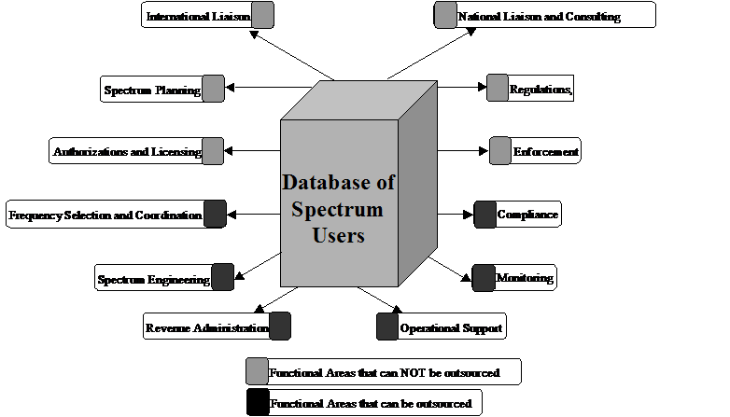

**Concession Principle**

An alternative solution to setup rapidly a modern and efficient spectrum monitoring system without capital expenditure by the State is to implant a concession. Instead of acquiring immediately systems and equipment’s to perform by itself all the Spectrum Monitoring tasks, the State Regulator grants a dedicated local company with a concession licence to perform these operational tasks according to specifications defined by the State Regulator: outsourcing of services

To incorporate the outsourcing concept into the spectrum management and control area means to adopt a new focus, based on shared responsibilities between public and private sectors, while increasing the level of capital investments and technological involvement of the latter. In outsourcing process, the main respective tasks of the concession are under:

* *Regulatory Responsibility*
* *Implement the legal and administrative framework in order to allow such a concession*
* *Concessionary Responsibility*
* *Performs the technical measurements*
* *Propose frequencies allocations*
* *Invoice the licences*
* *Collect the fees*

**ASSIGNMENT**

After considering the information and having understood the principle of outsourcing, kindly give your views of the outsourcing of Spectrum Management functions? You should explain:

* Pros and cons of Outsourcing?
* Would such outsourcing succeed in your country? (Every participant for unique country should answer this separately with reasoning)
* If outsourcing is done what should be Roles and Tasks of spectrum administrator and the company who is awarded outsourcing tender
* How to measure performance of outsourced company?
* Do such performance measurement parameter also apply to the national regulator?

**Your response should be in the form of presentation delivered by maximum 3 persons nominated by the group. The maximum time is 15 minutes. Views within group can be divergent and all views should be presented.**

***Note:*** *EXERCISE is based on document RGQ18/1/018-E submitted by Thales to ITU-D study Group RAPPORTEUR'S GROUP MEETING ON QUESTION 18/1: RIO DE JANEIRO, 21-22 APRIL 2004*