**Speaker Profile – Ren Hong**

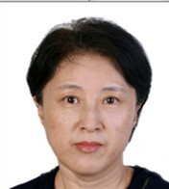

Senior Engineer

Frequency Engineering Department

State Radio Monitoring Center

Telephone: +86 010 68009091

Cell phone: +86 13439922501

Email: renhong@srrc.org.cn

Department: Beijing Monitoring Station

**Biography**

**EDUCATION**

* BEIJING UNIVERSITY OF POSTS AND TELECOMMUNICATIONS (Beijing, P.R.China,1985-1989), Electromagnetic Field and Microwave Technology

**WORK EXPERIENCE**

* **Frequency Engineering Department of the State Radio Monitoring Center , 2000-2017**

Senior Engineer

1. Satellite and earth station frequency coordination.

2. Bilateral frequency coordination for terrestrial service.

3. Examining the setting up of Stations and frequencies.

4. Taking part in the study of WRC agenda items and ITU meeting.

* **Radio Monitoring Department, State Radio Monitoring Center, 1989-2000**

Engineer

1. Setting up the radio monitoring systems.
2. Carry out routine monitoring and interference finding activities

2. Setting up VHF/UHF radio monitoring network.