Speaker Profile – Ying XU
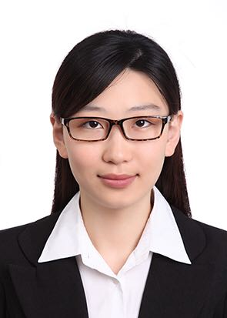
Ph.D./Engineer
Spectrum Engineering Department
The State Radio Monitoring Center

Telephone: +86 010 68009028
E-mail: xuying@srrc.org.cn

Biography
EDUCATION
- Beijing University of Posts and Telecommunications (Beijing, P. R. China, 2009 - 2014), Ph. D. Information and Communication Systems
- Beijing University of Posts and Telecommunications (Beijing, P. R. China, 2005 - 2009), B.E Electrical Engineering

WORK EXPERIENCE
- Spectrum Engineering Department, 2014 -Present
- Engaged in spectrum management, focuses on the coexistence and compatibility studies, coordination between systems and decisions on RF specifications.
- Temporary spectrum allocation or assignment for major events, such as G20 in Hangzhou, China.
- Research on emerging spectrum management methods, such as spectrum sharing, coexistence management.
- Study on methods of evaluating economic impact of the use of radio spectrum.
- Participated in the ITU-R and AWG standardization activities, heavily involved in the studies of several WRC-19 Agenda Items.

