**Speaker Profile – Tan WANG**

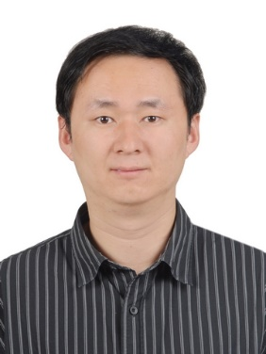

Senior Engineer

Spectrum Management Research Division of the State Radio Monitoring Center

Telephone: +86 010 68009273

Cell phone: +86 18610482400

Email: wangtan@srrc.org.cn

Department: Beijing Monitoring Station

**Biography**

**EDUCATION**

* **Ph.D.** in Communication and Information System, Beijing University of Posts and Telecommunications (BUPT), 2012.
* **B.S.** degree in Telecommunication Engineering, BUPT, 2007.

**SELECTED WORK EXPERIENCE**

* **Domestic:**

1. Directly support *Radio Regulation Bureau (RRB), MIIT*, in IMT frequency planning, sharing and compatibility studies, spectrum inventory and evaluation.
2. Leader of National Major Technology Project “*Analysis and evaluation of IMT-2020 candidate bands*” (2015-now)
3. Executive leader of *WRC-19 Agenda Item 1.13* in compatibility and sharing study. (2015-now)
4. Executive leader of *IMT-2020 (5G) Promotion Group - Spectrum Working Group*. (2013-now)
5. Executive leader of *WRC-15 Agenda Item 10: above 6GHz for IMT*. (2014-2015)
6. Executive leader of the *2015 National Radio Spectrum Inventory* and *2016 National Radio Spectrum Utilization Evlauation*.
7. Participated the revision of “*Regulations on the Radio Frequency Allocation of the People's Republic China*” after WRC-12 and WRC-15.

* **International:**

1. Focus on *ITU-R Task Group 5/1* (WRC-19 AI 1.13), *Study Group 5 Working Party 5D*, *Study Group 1 Working Party 1A/1B*, *Joint Task Group 4-5-6-7* (WRC-15 AI 1.1).
2. Chairmen of *ITU-R Task Group 5/1 Drafting Group of 26GHz Science (in-band).*
3. Head of Delegation of China on *ITU-R Task Group 5/1*. (2016-now)
4. Head of Delegation of China on *ITU-R Study Group 1 Working Party 1A*. (2013-2015)
5. Tutor of *ITU Centres of Excellence Network for Asia and the Pacific* on Spectrum Management (2016-now).