ITU Centres of Excellence Network for Asia and the Pacific

State Radio Monitoring Center - China

Training on

SPECTRUM ENGINEERING AND CROSS-BORDER RADIO FREQUENCY COORDINATION

Xi’an, Shanxi Province, China (Peoples Republic of)
11 – 15 September 2017

Practical Information for Participants

INTRODUCTION
The International Telecommunication Union (ITU) and the State Radio Monitoring Centre (SRMC), MIIT, China are organizing the ITU ASP CoE Training on Spectrum Management and Monitoring, from 11 to 15 Sep. 2017 in Xi’an, Shanxi Province, China.
This document provides some practical information on frequently asked questions about the events, including logistical details.

Training Venue
The events will take place at the NOVOTEL XIAN SCPG, Xi’an, Shanxi Province.
The contact details of the venue are as follows:
Venue: NOVOTEL XIAN SCPG, Xi’an, Shanxi Province.
Address: 33 Weiyang Road, Xi’an, Shanxi Province, 710016 P.R. China.

TRANSPORTATION

From Xi’an XIANYANG International Airport (http://www.xxia.com/) to the hotel:
SRMC will provide airport pick-up service. In order for us to make further arrangements for your stay, please inform us of your arrival/departure date and flight number.
By Public Transportation: From Airport Platform 5, take airport bus to Railway station and transfer to metro line 2, get off at Longshou Station;
By Taxi: 40 minutes, approximate RMB 80 Yuan;

Recommended Hotels
The NOVOTEL XIAN SCPG is four-star hotel with convenient public transport. It is adjacent to Xi’an metro line 2 (Longshou Station), 5 minutes to Bell Tower by metro, 15 minutes to CRH station, 30 minutes driving from hotel to Xi’an international airport.
The negotiated rate for accommodation (single room and one breakfast) is RMB450/room/night.

Passport and Visa
Citizens of other countries should possess a valid passport to enter China. The passport should be valid for at least 30 days after arrival date in China.
Citizens of some countries are required to obtain a visa in order to enter and stay in China. The visa must be requested and obtained from the Chinese Embassy/consulate in your country, or if there is no such office in your country, from the one that is closest to the country of departure.
In order to get the invitation letter for the VISA, please forward the registration confirmation email and send the copy of your passport to Ms. WANG Zhixia (office@srrc.org.cn) with a copy to Mr. Aamir Riaz (aamir.riaz@itu.int) before 30th of July 2017 the latest.

About China
The People's Republic of China is a socialist country with its own characteristics. China is a developing country and lies in the east of Asia. It is bordered by Russia and Mongolia to the north and North Korea to the northeast. To the south, its neighbors are Vietnam, Laos, Thailand and the Philippine. To the west and southwest India, Burma, Bhutan, Nepal and Pakistan. To the east Japan, which faces China across the East China Sea.
China is a vast territory of over 9,600,000 square kilometers. It has a population of more than 1.3 billion, which is a quarter of the world population. It consists of 34 provinces, autonomous regions, and municipalities directly under the Central Government. Beijing, which is situated in the Northeast of China, is the capital.
China is characterized by a continental climate. The latitude spans nearly 50 degrees. The greater part of the Chinese territory is situated in the Temperate Zone, its southern part in the tropical and subtropical zones, and its northern part near the Frigid Zone. Temperatures differ therefore rather strikingly across the country. The northern part of Heilongjiang Province has long winters but no summers; while the Hainan Island has long summers but no winters.
The People's Republic of China was founded on October 1, 1949. Today, China is implementing reform and opening-up policies, and has established socialist market economy, thereby charting the course for socialist modernization with Chinese characteristics.
Language and Character Chinese is commonly used in modern China. It is one of the six working languages designated by the United Nations and, as a written language; Chinese has been used for 6,000 years.

About Xi’an
Xi'an is the capital of Shaanxi province, located in the southern part of the Guanzhong Plain. With the Qinling Mountains to the south and the Weihe River to the north, it is in a favorable geographical location surrounded by water and hills. It has a semi-moist monsoon climate and there is a clear distinction between the four seasons. Except the colder winter, any season is relatively suitable for traveling. Xi’an is also one of the most important economic centers, transportation and communication hubs in Western China. According to the 2007 Public Appraisal for Best Chinese Cities for Investment, Xi’an was chosen as one of the top ten cities to invest in China.
The fertile Xi’an Plain, on which Xi’an is located, is also known as "the country of heaven", or more often seen translated as "the Land of Abundance". It was recently named China's 4th -most livable city by China Daily.
The cultural and historical significance of the area, as well as the abundant relics and sites, help Xi'an enjoy the laudatory title of 'Natural History Museum'. The Museum of Terra Cotta Warriors and Horses is praised as 'the eighth major miracle of the world', Mausoleum of Emperor Qin Shi Huang is listed on the World Heritage List, and the City Wall of the Ming Dynasty (1368 - 1644) is the largest and most intact Ming Dynasty castle in the world. In the city, there is the 3,000 year old Banbao Village Remains from the Neolithic Age (approximately from 8000 BC to 5000 BC), and the Forest of Stone Steles that holds 3,000 stone steles of different periods from the Han Dynasty to the Qing Dynasty.
Shanxi cuisine or Szechuan cuisine is a style of Chinese cuisine originating in the Shanxi Province famed for bold flavors, particularly the pungency and spiciness resulting from liberal use of garlic and chili peppers, as well as the unique flavor of the Shanxi peppercorn. Praised as 'the capital of table delicacies', Xi'an has been rich in the delicious Shaanxi snack, delicate Guangdong Cuisine, various kinds of fashionable foreign delicacies, and popular Sichuan Cuisine such as the hot pot. Among all the delicacies, the most famous and popular one is the Muslim Snack Street.

Transportation
Public Transportation in Xi’an consists of: subway, buses and taxi.

Health Care

Pharmacy and good medical facilities are largely available in Xi’an. Emergency medical services: 120

Useful Emergency Numbers

Police: 110

Fire Brigade: 119

Language
Chinese is the official language in China, but English is widely understood in major hotels, restaurants, banks and businesses. The training will be held in English.

Currency and Banking
The official currency accepted in China is RMB. Major foreign currencies September be exchanged to RMB at banks. Official banking hours can vary slightly, but in general are from 9:00 a.m. to 17:00 p.m. Banks are generally closed on weekends and holidays. The current exchange rate is approximately 6.8RMB to 1 US Dollar as of May 2017. Cash can be easily withdrawn 24/7 from the numerous ATMs spread in the city.

Credit Cards
Major credit cards (American Express, Diners Club, MasterCard, VISA and UnionPay card) are accepted by most hotels, restaurants, car rental agencies, department stores, but no small local shops. Usually there is a sticker at the entrance indicating which cards are accepted.

Climate
Temperature in September in Xi’an: Average high (C/F):26/79
Average low (C/F): 15/59
The suitable for wearing coat, shirts, shirt, skirts.

Local Time
The local time is UTC/GMT +8hours.

Tipping
Tipping is not customary in China.

Taxes
Usually the displayed prices have sales tax included in China.

Electrical Appliances
The standard power supply in China is 220 volts, the frequency is 50Hz. The type of power outlet/connector used in China is a two parallel outlet hole or three-hole outlet triangle. For the convenience of participants to use, we will provide wiring board, which is porous outlet.

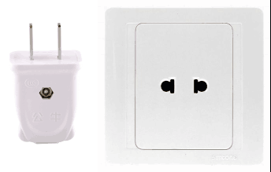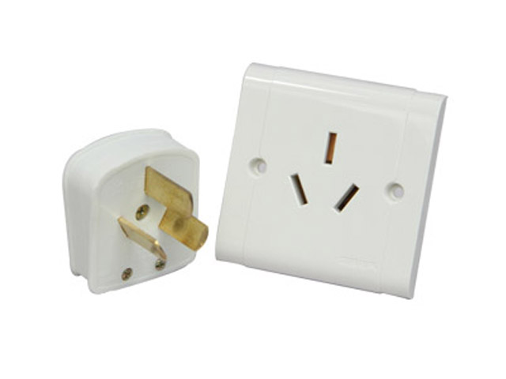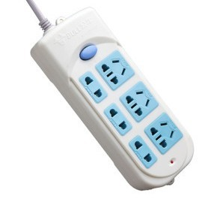
two parallel outlet hole three-hole outlet triangle wiring board

Calling Code
The national code of China is 0086 and Xi’an is 0086 29.

Buying a local SIM
China has three operators, China Unicom, China Telecom and China Mobile. Now buy a local SIM card in China requires real-name system purchase. Foreigners bring the passport in the operator’s business hall buy the local SIM card.

Driving

Cars in China have their steering wheel on the left and are driven on the right of the road. For additional information, please contact the following local coordinators:

Ms. Wang Zhixia (office@srrc.org.cn)

Mr. Andreas Christiono (andreas.christiono@itu.int)

Mr. Aamir Riaz (aamir.riaz@itu.int)
Have a nice trip to Xi’an!

