**ITU-FAO-DOA-TRCSL**

**Training on**

**“Innovation & Application Development for E-agriculture”**

**11-15 December 2017**

**National Agriculture Information & Communication Centre**

**Department of Agriculture**

**Peradeniya, Sri Lanka**

**supported by**

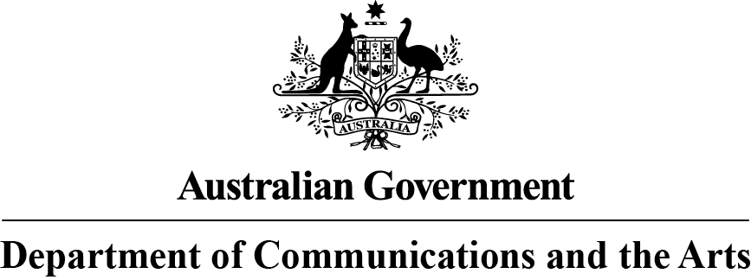

**Objectives**

ICTs play an important role in socio-economic development of a country through job creation and entrepreneurship. ICT based business can be a powerful tool for economic growth.

Keeping this importance in mind, ITU, TRCSL, Department of Agriculture and FAO initiated further training courses around “Innovation & Application Development for E-agriculture” in Peradeniya, Sri Lanka.

This training is the second training, after the first training which was carried out from 12-15 September, 2017 in Colombo, Sri Lanka.

The main objectives of the training course are to:

* A greater capability within the Department of Agriculture to innovate using emerging technologies;
* A greater ability to design, develop and deliver technology solutions to meet the development goals and challenges of the agriculture sector;
* Learn the processes and skills to design, develop and deliver a prototype application for Android devices
* Learn the processes and skills to design, develop and deliver a prototype web application using Ruby on Rails.

The training will consist of three components.

**Training 1**

1.5 days (approx. 30 participants)

Innovation and emerging technologies instruction

**Training 2**

1 day (approx. 20 participants)

Design, develop a simple Ruby on Rails application

**Training 3**

3 days (approx. 20 participants)

Design, develop and deliver a prototype application for Android devices

**Target Audience**

**Training 1**

This training is for a general audience of Department of Agriculture employees.

**Training 2 & Training 3**

This training is designed for a technical audience who have experience with designing and developing software.

**Medium of Instruction**

English

**ITU-FAO-DOA-TRCSL   
Training on “Innovation & Application Development for E-agriculture”**

**11-15 December 2017, Peradeniya, Sri Lanka**

**supported by**



**AGENDA**

|  |  |  |
| --- | --- | --- |
| 11th Dec, 2017– Day 1 | | |
| 08:30 – 09:00 | **Registration** | |
| 09:00 – 09:30 | **Opening Ceremony**   * Opening Remarks   + Mr. Sameer Sharma, Senior Advisor, ITU Regional Office Asia- Pacific   + Dr. D.B.T. Wijeratne, Assistant FAO Representative (Programme)   + Welcome Remarks: Director General, Department of Agriculture   + Welcome Remarks: Director General, TRCSL | |
| 09:30 – 10:30 | Keynote Address  ICT Trends, Innovation and Entrepreneurship | Mr. Sameer Sharma, Senior Advisor, ITU |
| 10:30 - 11:00 | **Morning Break** | |
| 11:00 –12:30 | **Business Optimization in Agriculture using ICTs**   * Challenges and Opportunities for agro-businesses * Use of ICTs in agro-business Examples * Programs available for incubation of small agro- businesses in Sri Lanka * Promotion, marketing and branding * Increasing Exports and access to International markets * Activity related to creating an online store using Shopify | Mr Shahryar Khan |
| 12:30 – 13:30 | **Lunch Break** | |
| 13:30 – 15:00 | **Innovation in the workplace**   * What is a culture of innovation? * Supporting and encouraging a culture of innovation in your workplace   + Hackathons, Hack days, other activities   + Education and training   + Leadership support   + Skunkworks   + Idea capture | Mr. Peter Argent |
| 15:00 – 15:30 | **Afternoon Break** | |
| 15:30 – 17:00 | **Social impact of improving innovation in:**   * Agriculture * Education * Health * Disaster management * Ecommerce * Banking | Mr. Sameer Sharma /  Mr. Shahryar Khan /  Mr. Peter Argent |

|  |  |  |
| --- | --- | --- |
| 12th Dec 2017 – Day 2 | | |
| 09:00 – 10:30 | **ICT enabled/based applications for business**   * Android and iOS applications * Challenges and opportunities for start-ups * Technical skills required to develop apps | Mr. Shahryar Khan |
| 10:30 - 11:00 | **Morning Break** | |
| 11:00 – 11:30 | **Leveraging Emerging Technologies for E-agriculture**   * Demystifying emerging technology * Leveraging Open Source tools and frameworks * Case studies of communities using future tech to solve challenges for the Agriculture sector | Mr. Peter Argent |
| 11:30 – 12:30 | **Lean Startup Design Processes**   * Define the problem to be solved * Propose a solution * Human Centred Design * User Experience Design * Personas * Business Model Canvas   Activity: In teams, propose a high tech solution to a challenge faced by Department of Agriculture | Mr. Peter Argent |
| 12:30 – 13:30 | **Lunch Break** | |
| 13:30 – 15:00 | **Developing Business Requirement and System** Requirements Document (Case Study from DoA) | Mr. Shahryar Khan |
| 15:00 – 15:30 | **Afternoon Break** | |
| 15:30 – 17:00 | **Developing Business Requirement and System** Requirements Document (Case Study from DoA) | Mr. Shahryar Khan |

|  |  |  |
| --- | --- | --- |
| 13th Dec, 2017– Day 3 | | |
| 09:00 – 1030 | **Introduction to web application development with Ruby on Rails**   * Ruby on Rails intro & demonstration * Development environment setup * Rails MVC * Open source tools * Deployment options | Mr. Peter Argent |
| 10:30 - 11:00 | **Morning Break** | |
| 11:00 –12:30 | **Create the basic application**   * Basic Rails commands * Rails project tour * Theme with Bootstrap * Static pages | Mr. Peter Argent |
| 12:30 - 13:30 | **Lunch Break** | |
| 13:30 –15:00 | * Authentication with Devise * Authorization with Rolify, Cancan * Other gems | Mr. Peter Argent |
| 15:30 – 16:00 | **Afternoon Break** | |
| 16:00 – 17:30 | **Create CRUD functionality**   * Add data structures and CRUD functionality * Modify Model, Views and Controllers for desired functionality | Mr. Peter Argent |

|  |  |  |
| --- | --- | --- |
| 14th Dec, 2017– Day 4 | | |
| 09:00 – 1030 | **Introduction to Mobile app development** | Mr. Shahryar Khan  Mr. Sameer Sharma |
| 10:30 - 11:00 | **Morning Break** | |
| 11:00 –12:30 | **Introduction to Android platform and android development environment**   * Overview of android platform * Understanding its development environment   Creating a “Hello World” program | Mr. Shahryar Khan  Mr. Imran Tanvir |
| 12:30 - 13:30 | **Lunch Break** | |
| 13:30 –15:00 | **The basics**   * Application fundamentals   The activity class | Mr. Shahryar Khan  Mr. Imran Tanvir |
| 15:30 – 16:00 | **Afternoon Break** | |
| 16:00 – 17:30 | * Developer classes * The intent class * Navigation and Tab bar | Mr. Shahryar Khan  Mr. Imran Tanvir |

|  |  |  |
| --- | --- | --- |
| 15th Dec, 2017– Day 5 | | |
| 09:00 – 1030 | **List Views and Fragment Classes** | Mr. Shahryar Khan  Mr. Imran Tanvir |
| 10:30 - 11:00 | **Morning Break** | |
| 11:00 –12:30 | * User interface class * Text fields, Buttons and Labels | Mr. Shahryar Khan  Mr. Imran Tanvir |
| 12:30 - 13:30 | **Lunch Break** | |
| 13:30 –15:00 | **User Interface Classes**   * Map Views * Image Picker * Web View * Data Persistence | Mr. Shahryar Khan  Mr. Imran Tanvir |
| 15:30 – 16:00 | **Afternoon Break** | |
| 16:00 – 17:30 | **Concluding Session** |  |