**Brief Resume**

**Aurora A. Rubio**

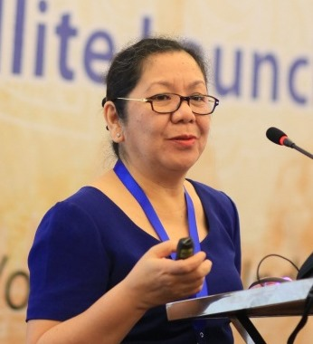Aurora A. Rubio is the Head of the ITU Area Office for South East Asia, based in Jakarta, Indonesia. She joined ITU in 2005 and has since then been working on the promotion of telecommunications development through direct country and sub-regional actions, advisory services, and capacity building in the Asia-Pacific region. The ITU Area Office for South East Asia covers at least 10 countries in region which include four least developed countries and three low income developing countries. She has implemented initiatives and projects in partnership and collaboration with international and regional organizations, e.g. ADB, ASEAN, UNESCAP, UNICEF, WHO, UN Women, Asia-Pacific Broadcasting Union (ABU), Asia-Pacific Telecommunity (APT), Telecentre.org, and the Asia-Pacific Women Information Network Center (APWINC).

Ms. Rubio is involved in ITU development activities particularly on areas related to digital inclusion, telecommunication policy and regulations, cybersecurity, capacity building on ICT Indicators and Statistics.

Ms. Rubio graduated with the Degree in Electronics and Communications Engineering in 1977 from the University of Santo Tomas, Philippines and Masters Degree in Electrical Engineering Education in 1979 from the University of the Philippines.

Before joining the ITU in 2005, Ms. Rubio worked at the Department of Transportation and Communications of the Philippines from 1988 to 2005. She was directly involved in a number of important projects, strategy planning and policy development that introduced early competition in the Philippine telecommunications sector.

Ms. Rubio has 12 years academic experience as professor in the Faculty of Engineering at the University of Santo Tomas from 1977-1989. She was actively involved in the activities and work of the Institute of Electronics and Communications Engineers of the Philippines (IECEP), an association of professional electronics engineers where she was IECEP President in 2004. She is an accredited ASEAN professional electronics engineer.