# Short Bio Peter Walop (May 2016)

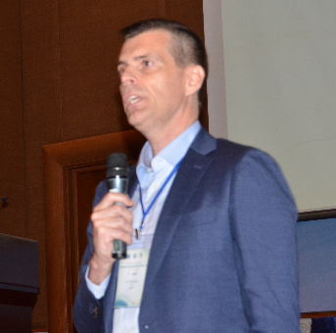

Peter Walop has over 20 years of experience in the broadcast and telecom markets and led many service launches and company restructuring processes.

As an ITU expert, Peter assisted African, Asian and Caribbean countries in migrating from analogue to digital broadcasting, including Angola, Bhutan, Burundi, Cambodia, Ethiopia, Jamaica, Thailand and Rwanda. Peter is co-author of the ITU “Guidelines on the Transition from Analogue to Digital Broadcasting”. Peter is also co-author of the ITU’s reports on the Digital Dividend, titled “Digital Dividend: Insights for Spectrum Decisions” and Interactive Multimedia Services in Asia Pacific: Trends and Insights. Currently he is assisting the Thai National Regulatory Authority (NBTC) with the introduction of digital television and radio services.

For the European Union he helped the Serbian government in planning the digital television switch-over. He also assisted key broadcast players in Sweden (Boxer) and Belgium (VRT/PMV) in respectively repositioning the digital television offer and the sales of the national broadcast network assets. For a leading Belgium commercial broadcaster he provided strategic advice on the introduction of mobile television services (DVB-H and 3G).

Peter previously worked for Nozema, the Dutch broadcast network operator, as deputy CEO. As a member of the management team he launched digital and mobile television as well as wireless internet services in the Netherlands. The launch of the mobile television services (DVB-H) was prepared and carried out in close cooperation with the Dutch incumbent telecom operator (KPN) and Nokia.

In the past he worked for Hewlett Packard in the UK and he joined Coopers & Lybrand Management Consultants (now PwC) for 9 years. For the latter company he carried out numerous assignments in the broadcast and telecom industry, for both operators and Regulators in the Netherlands, Germany, Spain and the UK. Peter also worked for Accenture for 2 years and carried out assignments for global broadcast operators based in Paris (TDF) and Luxembourg (SES), including the business planning for digital and mobile television.

Peter holds a Master degree in Organizational Analysis & Behavior of the University of Lancaster, the United Kingdom, as well as a Master degree in Business Informatics of the Erasmus University Rotterdam, the Netherlands. He started his academic career with completing a Bachelor degree in Production Engineering, Polytechnic Dordrecht, in the Netherlands.