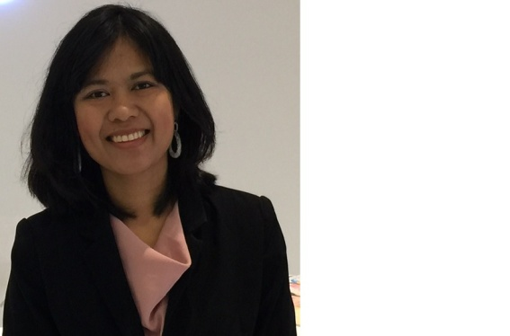

Ms.Orasri Srirasa,

Expert/Acting Division Director of Digital Broadcasting Bureau, Office of National Broadcasting and Telecommunications commission (NBTC), Thailand

She has 20 years of experience in digital broadcasting and telecommunications. Her professional experience in implementing Digital Terrestrial TV in Thailand, developing Digital Radio Broadcasting roadmap and roll-out plan, Mobile Television Services Feasibility Study and leading on project Community TV framework development and implementation. Her background includes telecommunication engineer in Mobile Network and Fixed Network Planning and Operation, Service Quality Management, Applications and Software Development, and Data Intelligent Analysis, etc.

Prior joining Office of NBTC, she worked for ITU/NBTC joint projects on digital broadcasting, and telecom companies such as True Corporation, Hutchison Wireless, and TT&T. She involved in 3G network and fixed line network planning and implementation, IT applications development, E2E performance management and device testing.

Orasri holds Master Degree in Information Technology, Bachelor degree in Engineering from King Mongkut University of Technology Thonburi (KMUTT) and Finance from Ramkhamhaeng University (RU), Thailand