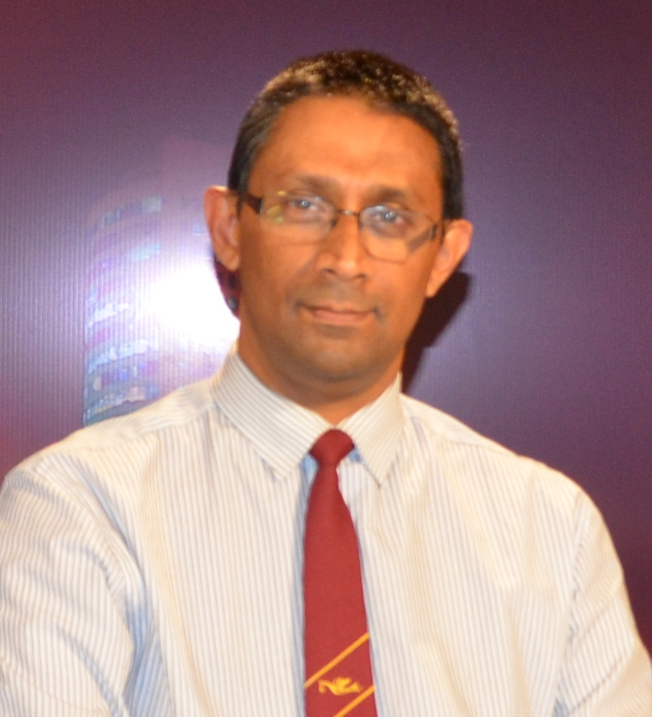

Dr Amal Punchihewa
Director Technology & Innovation of ABU
A Vice-Chair of World Broadcasting Union Technical Committee

Amal graduated with BSc (Eng) Hons specialised in Electronics and Telecommunication Engineering from Sri Lanka, MEng from Technical University of Eindhoven, the Netherlands & PhD from Massey University in New Zealand. He has published over 100 scholarly articles (peer-refereed technical journal and conference articles) in various journals including IEEE and IET digital libraries and transactions. He has held visiting positions at Tokyo University of Science (Japan) as a visiting associate professor and visiting professor. He was a Royal Dutch fellow of Netherlands and Japan Society for the Promotion of Science (JSPS of Japan). He has served on technical/programme committees, organizing committees and as track/session chairs for many international conferences. He advises on many International conferences including CCBN conference in China, BES in India and BCA in Singapore. Amal is a Senior Member of IEEE, Chartered Professional Engineer-CEng, Fellow of IET (UK) & Fellow of IPENZ (New Zealand).
Amal is currently Director Technology & Innovation at ABU. In that position, Amal drives innovation of media technology in the complete chain of media, starting from acquisition to consumption in the broadcasting industry. He influences the development of media technology in the best interest of ABU members. He leads a team of specialists, he facilitates technical guidelines and standards, and provides expertise related to the convergence of media, and evolving technical needs. He creates, encourages, and manages member communities, and understands and explains the trends that shape the media, to empower Members to continue to take good strategic decisions.
He ensures that the Department continues to be a vital and respected partner for its members and for the media industry. As a member of the ABU Headquarters Management Team, he also plays a major part in shaping ABU strategy.
Amal is active in many of the WBU-TC and ITU broadcast related technical activities. He is a vice chairman of the WBU-TC. He is an advisor to IET Vision and Imaging Professional Network having served as an executive of IET Vision and Imaging Professional Network.
He possess more than 30 years of experience in all three sectors of broadcasting; viz. Academia, Research and Industry in senior broadcasting technology and ICT roles, including research and developments, regional capacity building in media and head of engineering of national TV-Sri Lanka, having started career in computer engineering.

