 | ITU-TRAI Training on Consumer Protection  21 – 23 March 2016  New Delhi, INDIA  BIOGRAPHY | 

Session | 02
Title of presentation | Monitoring broad band quality of service
[Photo here] 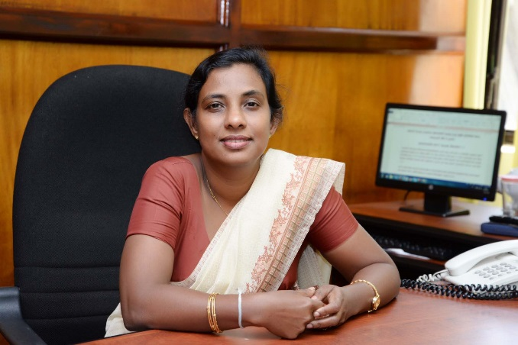 | [Name] Menaka Pathirana  [Title] Deputy Director  [Organization Name] Telecommunications Regulatory Commission
Ms.Pathirana has been working in the Telecommunications Regulatory Commission in Sri Lanka during last 18 years.
She has been graduated in Business Management and completed her masters in Madurai Kamaraj University

She is responsible for handling consumer complaints and engage in wide range of awareness programmes in Sri Lanka.
Consumer complaints handling procedure has been simplified by arranging one to one relationship with telecom operators.
She has initiated awareness programme on ethical usage of communication and media over print media as well as through digital media.
She has done a publication on ethical use of mobile phones of which fourth edition was released within one year of its first publication.

.

