 | ITU-TRAI Training on Consumer Protection  21 – 23 March 2016  New Delhi, INDIA  BIOGRAPHY | 

Session | 23 March, 10.30-12.00
Title of presentation | Consumer Protection in Era of Online Services : EU
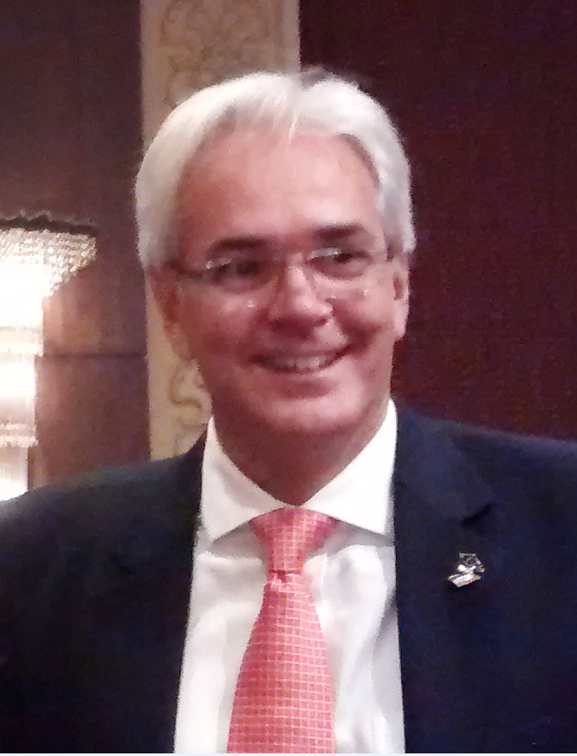 | Klaus Pendl  First Counsellor – ICT  Delegation of the European Union to India
 | Dr. Pendl works in the Trade and Economic Section of the Delegation of the European Union to India, and is responsible for ICT matters (market access, standardisation, research and innovation, Internet Governance). He previously worked in the European Commission’s Directorate General for Communications Networks, Content and Technology (DG CONNECT) in Brussels. Before, he was a head of unit in the Austrian Prime Minister’s Office, and worked at Danube University Krems and at the EFTA Surveillance Authority.

