 | ITU-TRAI Training on Consumer Protection  21 – 23 March 2016  New Delhi, INDIA  BIOGRAPHY | 

Session | Session 1
Title of presentation | Consumer Issues
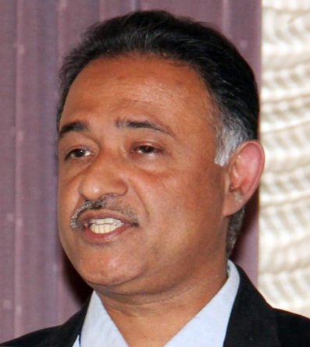 | George Cheriyan, Director, CUTS International
George Cheriyan is Director of CUTS International, and heads the CUTS Centre for Consumer Action, Research & Training (CUTS CART), one of the programme centres of CUTS, based in Jaipur, India, since 2003.

Presently George is a member of the Council of Consumers International, which is the world federation of consumer groups, based in London, UK. He was awarded the prestigious Rodha Karpatkin International Consumer Award in 2013 by American Council on Consumer Interests (ACCI).

George is a member of the Central Consumer Protection Council (CCPC) of Government of India, since 2007 and a member of the Central Advisory Committee (CAC) of the Food Safety and Standards Authority of India (FSSAI).

He was part of the Government of India delegation to the Third Expert Group Meeting on the revision of United Nations Guidelines on Consumer Protection (UNGCP) organised by UNCTAD in Geneva in January, 2015.

Exposure from traveling in 26 countries and have experience of consulting for bilateral and multilateral agencies, other than India, in Nepal, Sri Lanka, Bangladesh, Cambodia, Vietnam, Uganda, Kenya, Egypt and Yemen.

He was Member of Committee for Utilization of Telecommunication Consumers Education and Protection Fund (CUTCEF) of TRAI from April 2011 to March 2012.

