 | ITU-TRAI Training on Consumer Protection  21 – 23 March 2016  New Delhi, INDIA  BIOGRAPHY | 

Session | Session 4
Title of presentation | Framework of QoS monitoring and implementation in India
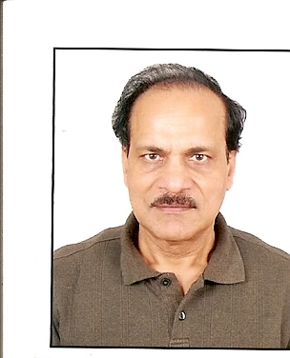 | Chandra Prakash  Member(T), DoT Retd.
Mr. Chandra Prakash has an experience of over 37 years of working in Dept. Of Telecom, BSNL and TCIL in various capacities. During his service period, he started his career in planning, Installation and commissioning of transmission systems in Telecom Projects. Then he moved to operation and maintenance of long distance transmission systems. He had an instinct of 5 years with TCIL in Projects of Telecom expansion in Kingdom of Saudi Arabia.
He worked in BSNL in Telecom District and as Circle head responsible for operations of Telecom services in the largest circle of India.
Finally, he was posted as Member(Technology), Telecom Commission in DoT with responsibilities related to Telecom Licensing, Wireless planning and co-ordination, International relations, security and Telecom Engg centre.

