 | ITU-TRAI Training on Consumer Protection  21 – 23 March 2016  New Delhi, INDIA  BIOGRAPHY | 

Session | Session 2
Title of presentation | Consumer Interest Initiatives of TRAI
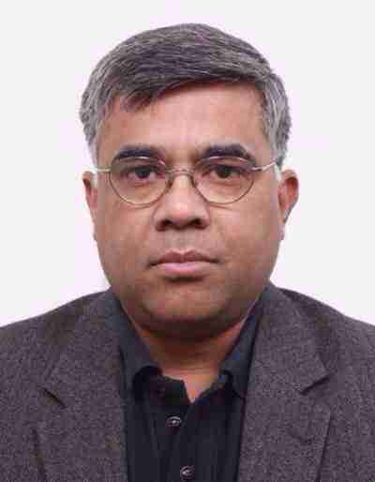 | Agneshwar Sen  TRAI HQ New Delhi
Mr Agneshwar Sen, is the Advisor (Consumer Affairs), at the TRAI HQ. In this role he is instrumental in organizing all consumer outreach activities of TRAI, that includes arranging outreach programs all over India; finalization and publication of a variety of information material and public interest advertisements.

On deputation from the Dept. of Commerce Government of India, Mr Sen has wide ranging experience in multilateral and bilateral trade negotiations, including as India’s representative in the World Trade Organization, Secretariat and at the Permanent Mission of India to the WTO. His area of expertise includes negotiations on industrial goods; Government Procurement; Electronic Commerce; and Regional Trade Agreements.

He has been on several capacity building and technical assistance missions in Asia and Africa. He lectures on trade policy; WTO; and related issues at the IIM Calcutta, Indian Institute of Foreign Trade, Institute of Chartered Accountants of India, Institute of Cost Accountants of India, amongst others.

