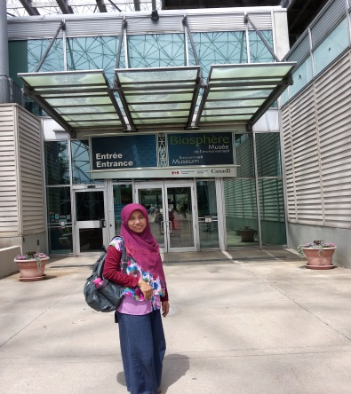

**Biography**

**ENI LESTARININGSIH**

WORKING EXPERIENCE

Eni Lestariningsih, S.Si, MA. is:

The Head of ICT Statistics Division, BPS-Statistics Indonesia (since 2013).

She responsibles to manage the provision of ICT Statistics in Indonesia. Every year, the division of ICT Statistics conducts three kinds of surveys, namely:

1. Survey on ICT Usage in Business Sector and Education Sector:

coverage 3,964 respondents in 33 Provinces of Indonesia, that is consist of:

1. Business (manufacturing, trade, restaurant, and hotels);
2. b. School at primary until High School level;
3. Survey on Information and Communication: coverage 1000 establishments in the sector of information and communication industries;
4. Survey on Telecommunication Statistics: this is mainly collected based on secondary data.

Besides of that, since 2014 the ICT Statistics Division put intensive effort to develop the ICT Development Index at Sub-National Level of Indonesia.

EDUCATION EXPERIENCE

* Eni gained her Master Degree in Economics from Tokyo International University, Japan, under MONBUSHO Scholarship (2004-2006).
* Eni is now as PhD Candidate in Management of HR from University of Jakarta, Indonesia (since 2015).