 |  | ITU-PTA Regulators’ Roundtable  18 - 19 July 2016  &  ITU-PTA International Training Program  20 - 22 July 2016  Islamabad, Pakistan | 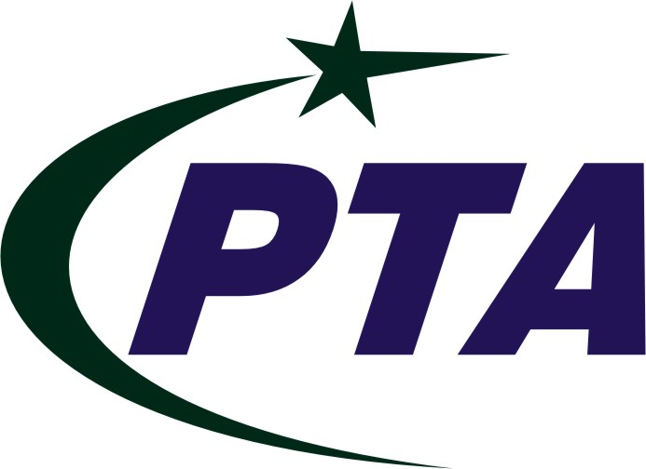
PARTICIPANT INFORMATION

VENUE
Islamabad Serena Hotel
Address: Aga Khan Road, Shalimar 5-PO Box1251, Islamabad 44000, Pakistan
Tel: +92 51 287 4000
Fax: +92 51 287 1092
URL: http://www.serenahotels.com/serenaislamabad/default-en.html
HOTELS

No. | Name of the Hotel | Room Rate  (Approx. per night)
1 | Islamabad Marriott Hotel  Address: Aga Khan Road, Shalimar 5-PO Box1251 Islamabad 44000 Pakistan  Tel: +92 51 2826121  Fax: +92 51 2825113  URL: http://www.marriott.com/hotels/travel/isbpk-islamabad-marriott-hotel | USD 190-225
2 | Islamabad Serena Hotel  Address: Khayaban-e-Suhrawardy  Islamabad  Tel: +92 51 287 4000  Fax: +92 51 287 1092  URL: http://www.serenahotels.com/serenaislamabad/default-en.html | USD 250
3 | Hotel Margala  Address: M2 near Convention Centre Islamabad, Pakistan  Tel: +92 51 111 901 901  Fax: +92 51 2274 054  Email: isb@hotelmargala.com  URL: http://www.hotelmargala.com | USD 85-120
4 | Best Western Islamabad Hotel  Address: 6-Islamabad Club Road, Islamabad, Pakistan.  Tel: +92 51 2277460 upto 8  Fax: +92 51 2271538 and 39  Email: mail@bestwesternisb.com  URL: http://www.bestwesternisb.com | USD 70-105

IMMIGRATION REQUIREMENTS
All foreigners coming to Pakistan need a valid passport. Pakistan Missions abroad are authorized to grant Visit/Tourist Visa for three months validity and stay with double entry to foreigners of 175 countries. Participants are requested to contact Pakistan embassy in their country and ensure that they possess visa for the period of stay in Pakistan. For more information about the countries list and Visa info please click here for Visa Category or follow the link below:
URL: www.dgip.gov.pk/Files/Visa%20Categories.aspx
For quick info about Visa Policy, Visa Categories and Immigration Policy, you can also visit direct links as follows:
Visa Policy: www.dgip.gov.pk/files/Visa.aspx
Visa Categories: www.dgip.gov.pk/Files/Visa%20Categories.aspx
Immigration Policy: www.dgip.gov.pk/Files/Immigration.aspx
For Visa Facilitation letter contact points given at the end of this document may be contacted with following documents:
- Recent photograph
- Copy of Passport (six moth validity is required)
- National ID Card copy (if any)
- Confirm E-ticket
- Confirm Hotel Booking
TRANSPORTATION & AIRPORT PICK/DROP
Most of the Hotels in Islamabad provide complimentary pick and drop facility to / from Benazir Bhutto International Airport (BBIAP). In addition to above, the facility of Radio Cabs and car rental services can be availed from reception desk of hotels at reasonable rates.
The easiest mode to travel in twin cities is by yellow cab taxi. Although the Taxi service in Islamabad/ Rawalpindi is satisfactory, but are non-air-conditioned. Furthermore, they are not controlled by any centralized agency. The taxis in Islamabad are almost all black with a yellow painted roof and you'll have no trouble in hiring the same. Passengers are suggested to bargain and decide the fare before start of journey.
In addition to hiring a yellow cab one can utilize the services of more comfortable air conditioned Taxi/Cab service for moving to/from Airport to any specific location or by calling the cab at any location in Islamabad. Following cab service is available at BBIAP Islamabad.

- METRO RADIO CAB
Concourse Hall, Islamabad Airport
24 hours call center No.
UAN: +92-51-111-222-787
Tel: +92-51-5872236
URL: http://www.metrocab.com.pk
HEALTH REQUIREMENTS
ITU requests all participants to ensure medical and travel insurance covering the whole period of the overseas travel. Neither ITU nor PTA will be able to meet any expenses relating to injury, accident or medical treatment of the participant.

OTHER INFORMATION

PRACTICAL INFORMATION ABOUT ISLAMABAD, PAKISTAN
Combining a rich history, the confluence of many a civilization and temperate climate, Islamabad - the capital city of Pakistan, is one of the most beautiful cities in the South Asian region. Wide, tree-lined streets adorn the various sectors and zones of the city, making it accessible and spectacular. Administratively, the city is located within the Islamabad Capital Territory, which is federally controlled, even though historically Islamabad has been a part of the Punjab province; more specifically the Potohar Plateau. The city was built between 1960 - 1970 to replace Karachi as the capital. It has a population of 2 million and together with its neighbouring twin city of Rawalpindi, the greater Islamabad-Rawalpindi metropolitan area is the third largest in Pakistan with a population of over 4.5 million inhabitants.
Following website contains useful information about Islamabad:
http://www.islamabad.gov.pk/

WEATHER
The month of July is characterized by falling daily high temperatures, with daily highs decreasing from 37°C to 33°C over the course of the month, exceeding 41°C or dropping below 29°C only one day in ten.
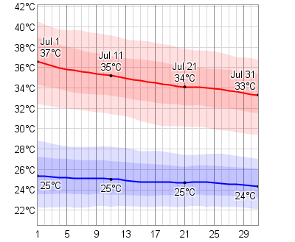

TIME ZONE
Pakistan is covered by a single time zone. Local time is GMT +5.
BANKS & CURRENCY
The Pakistani currency unit is Rupee. Travellers cheques (best carried in US Dollars or Pounds Sterling) are accepted at most banks, four and five star hotels and major shops. It is recommended that participants may keep some US Dollars in cash for expenses in Islamabad. However, larger shops and hotels accept credit cards, mostly VISA, MasterCard and American Express. Bank hours are from 9am to 5pm Monday to Thursday, 9am to 12:30pm & 2:30pm to 5:30pm on Fridays. Bargaining is expected in street markets and small stores.
CURRENCY EXCHANGE
One US Dollar can be exchanged for about 100 Pakistani Rupees. Euros, Pound Sterling, and other major currencies can be easily exchanged. Foreign currency in cash is allowed up to a limit of 5000 USD (equivalent). Currency exchange facilities are available in most banks and (registered) currency changers as well as the airport. Major hotels also provide currency exchange facility but may charge commission. Exchanging money in the street is not advisable.
Market exchange rate may be obtained from State Bank of Pakistan:
http://www.sbp.org.pk/ecodata/rates/m2m/M2M-Current.asp
COMMUNICATION
The international dialling code for Pakistan is +92. The outgoing international code is 00, followed by the relevant country code (e.g. 0027 for South Africa). City/area codes are in use, e.g. (0)51 for Islamabad, (0)21 for Karachi. There are five GSM 900 and 1800 mobile networks in operation, providing fair coverage, concentrated in urban areas. Internet cafes and Wifi environments exist at most places in the city.

EMERGENCY NUMBER
Emergencies Police: 15
Fire Brigade: 16
Ambulance: 115
Ambulance/Rescue: 1122
ELECTRICITY
Electrical current is 230 volts, 50Hz. Round two- or three-pin plugs are used. For other types of plugs converters are easily available in the market.

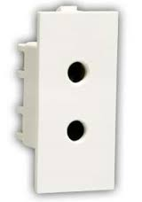
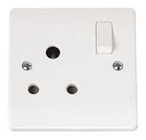
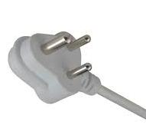
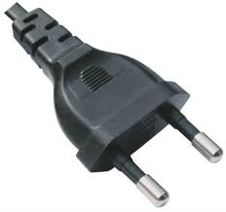

CONTACT POINT
For any further information you may require or if you need a personal invitation letter or official document for your travel clearances, please contact:

Mr. Ahmed Shamim Pirzada,
Director (Coordination),
Pakistan Telecommunication Authority
Islamabad.
Tel: +92-51-9212347
Fax: +92-51-2879978
E-mail: ahmedshamim@pta.gov.pk

Mr. Ali Waqas Raza,
Assistant Director (Coordination),
Pakistan Telecommunication Authority
Islamabad.
Tel: +92-51-9225219
Fax: +92-51-2879978
E-mail: aliwaqas@pta.gov.pk

Mr. Ali Mardan Solangi,
Liaison Officer (Coordination),
Pakistan Telecommunication Authority
Islamabad.
Tel: +92-51-9225313
Fax: +92-51-2879978
E-mail: amsolangi@pta.gov.pk

