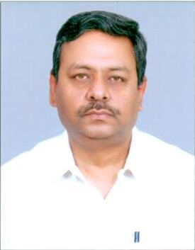

Mr. U. K. Srivastava is Principal Advisor in Telecom Regulatory Authority of India, looking after telecom networks, spectrum and licensing. He is a graduate in Electronics Engineering and possesses Diploma in Management.

He is trained in transmission technologies, including optical, radio and satellite communications. He has managed various telecom activities including operations, maintenance, training, quality assurance, standardization and policy. He has been a member of various standing committees on satellite communications.

He was deputed to ITU to serve in Iraq for two years and at ITU HQ in Geneva for a year and half.

He has been associated with various standards development activities of ITU-T and ITU-R and has represented India in various conferences of these organizations. He also served as Vice Chairman of Study group-7 of ITU-R for a period of four years.