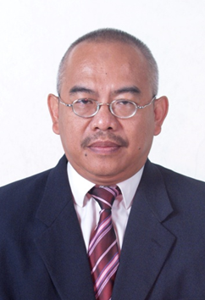

Dr. Rony Mamur Bishry is one of the 9 Commissioners specializing in macro economics affair at the Indonesian Telecommunication Regulation Authority.(BRTI). He was granted Fulbright Senior Researcher Program in Economics in 2001at Michigan State University, USA. He received PhD Degree in Economics in 1991 from The University of Illlinois at Urbana Champaign, USA. He was a senior Economic researcher at the Agency for The Assessment and Application of Technology (BPPT) Indonesia. (1991-2015).

