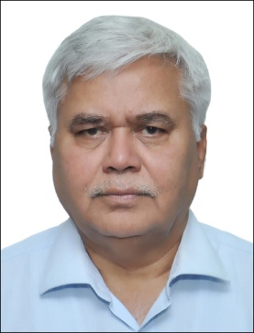

Mr. R.S.Sharma joined as Chairman, Telecom Regulatory Authority of India (TRAI) on 10th of August, 2015. Prior to joining TRAI Mr. R.S.Sharma was working as Secretary to Government of India in the Department of Electronics and Information Technology. He has also worked as Chief Secretary to the State Government of Jharkhand (India). His other assignments include Director General & Mission Director of the Unique Identification Authority of India (UIDAI) where he was responsible for over-all implementation of this ambitious and challenging project undertaken by the Government of India for providing Unique Identification (christened as Äadhaar”) to all its Residents.

Before his posting at UIDAI, Mr. Sharma worked with the Government of Jharkhand as Principal Secretary of the Departments of Science and Technology, Drinking Water & Sanitation, Information Technology (IT), Rural Development and Human Resources Development. As Principal Secretary of the IT Department, Mr. Sharma was responsible for formulation of State policies in the IT and e-Governance areas. He also over-saw the implementation of various e-Governance Projects in all the Departments of the State Government.

Mr. Sharma has held important positions both in the Government of India and State Governments in the past and has been deeply involved in the administrative reforms and leveraging IT to simplify the administrative processes. During his posting in Government of India, he has worked in the Department of Economic Affairs and has dealt with bilateral and multilateral development agencies like World Bank, ADB, MIGA and GEF. He was also in-charge of Financing of Infrastructure projects in the Highways, Ports, Airports and Telecom sectors. Mr. Sharma's contributions to the IT and e-Governance have been widely recognized both within India and outside. He has been responsible for implementing a number of Projects relating to ICT Infrastructure, Process Re-engineering and Service Delivery in Public Private Partnership (PPP) mode. Mr. Sharma holds a Masters Degree in Mathematics from IIT, Kanpur (India) and another Masters in Computer Science from the University of California (USA).