CURRICULUM VITAE

Personal Data  Name : Heru Sutadi  Place/Date of Birth : Jakarta, April 1, 1970  Mobile : +62818121470  Email : hersut@outlook.com | 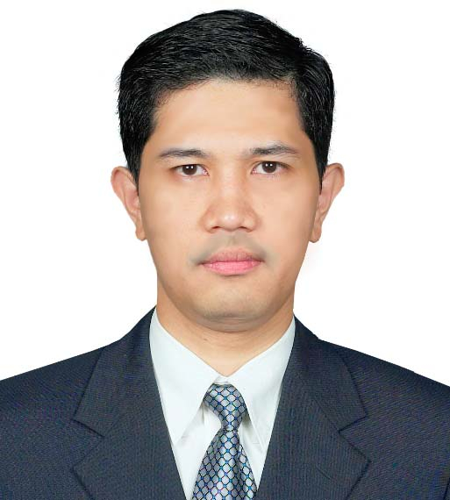

EMPLOYMENT
- Executive Director Indonesia ICT Institute (May 2012-now).
Job Description: Directing all activity in Indonesia ICT Institute (IdICTi), responsible for P/L. and provide leadership to all staff of the Executive Office. The IdICTi is a profesional institution to the study (regulation, new technology adoption), research (telco and internet business in Indonesia and ASEAN, cloud computing, Big Data, pricing, interconnection, spectrum fee, e-commerce, e-banking, content and applications), public empowerment/corporate social responsibility (CSR), and giving consultancy about policy and regulatory issues in the communications and media industries (risk management, auditing, business competition, disassater recovery, data center architecture). IdICTi also organizes leading national and international ICT conferences, discussion and workshops, established some forums and research regarding telecommunication, broadcasting and online media. Following scope of business, I have to develop and maintain the common vision of the overall role of the IdICTi communicate the vision to government, corporate sectors, non-government and international community, and also to oversee the preparation of the strategy and the annual work plan and budget of the IdICTi to be submitted for approval to the Commisioner Board. In IdICTi, I have to responsible for the execution of the day-to-day operations including resource mobilization , coordination with onother board of the directors, clients and board of the commissioners as well. Indonesia ICT Institute also published ICT e-magazine (www.majalahict.com) and I am responsible as chief editor.
- Commissioner of Indonesian Telecommunication Regulatory Authority (2006-April 2012)
Job Description: Regulating, controlling and monitoring telecommunication industry in Indonesia especially correlated with licensing, telco business analysis, managed service, spectrum frequency management, numbering, interconnection, competition, universal service obligation, tariff, national infrastructure and broadband policy, consumer protection, and broadcasting industry (frequency and digitalization TV). Some target we have to achieve: WSIS, ASEAN ICT MasterPlan, Indonesian Economic Growth Accelleration, and MDGs growth, trade, finance for development, and statistics at the national and international levels. From this experiences, I was used to and strong understanding and knowledge of the policy-making on trade issues; research, innovation and technology; finance for development; data collection and analysis/national statistics.
- Project Director in Mitra Bisnis Integrasi Co. (2001-2005).
Job Description: Direct and manage projects/program with high risk and complexity ensuring final delivery to meet customer's expectations of time and quality. Ensure program/project complete within budget by efficient cost controlling and internal and external resources management. Acts as primary project interface to the customer ensuring good customer satisfaction and developing the customer relationship. Shares project experience and knowledge of project management provide project management consultation and training to junior staff members. Manage the projects/program in pre-sales stage, prepare project management proposal, BOQ, etc, as well as proposal presentation to customer and contract negotiation. Some project are: In Building roll out for some Indonesian telco operator, VSAT sateliite, fiber optic network in some cities, software development and Sitac/CME activity for new BTS, risk management, data center planning, dissaster recovery, Telco and IT auditing.
- Telco Project Manager for software verification and integration in Lucent Technologies - Germany (1999-2001).
Job Description: Responsible for developing, testing and maintaining new and existing applications within telecommunication equipment. My role focus on creating automated test suites for designated software features, performing system testing, executing tests, checking results and resolving problems. I also have to contribute to the improvement of procedures and work practices and ensure products match the expected.
- Senior Transmission Consultant in Lucent Technologies – Saudi Arabia (1998-1999)
Job Description: Implementing and testing fiber optik networks using Lucent Technologies’s Synchronous Digital Hierarchy (SDH) transmission equipment and DWDM as well.
- Senior Engineer in Alcatel Indonesia dan Alcatel Philippines (1996-1998)
Job Description: Implementing and testing fiber optik networks using Alcatel’s Synchronous Digital Hierarchy (SDH) transmission equipment and DWDM as well.

CONTRIBUTIONS AND PROJECTS
- Speaker in CommunicAsia, Singapore, 2015
- Speaker in the Mobile and Internet Show, Singapore, 2014
- Speaker in the Card and Payment Asia, Singapore, 2014
- Speaker in the Big Data Workshop, PulsaLab, Bali, 2013
- Speaker in the 7th Annual Mobile VAS Conference, 2013
- Speaker in the Big Data Conference, 2012
- Founder and Coordinator Indonesia LTE Forum, 2012
- Speaker in the Card and Payment Asia, Singapore, 2012
- Speaker in the Cloud Security, Governance and Standard Asia, Singapore, 2012
- Head of Indonesian Delegation in ITU-Asia Pacific Regulatory Roundtable, Melbourne, Australia (2011)
- Speaker in the Advance Spectrum Frequency Management, Almaty, Kazakhstan, 2011
- Speaker in the LTE World Forum, Amsterdam, 2011
- Speaker in the Broadband Forum Asia, Kuala Lumpur, 2011
- Speaker in the WiMax Forum Asia, Kuala Lumpur Malaysia, 2010
- Speaker in the FutureGov Forum Indonesia, 2010
- Speaker in the ITU/MIIT Seminar on Convergence of Industrialization and ICT, Guangzhou, China, 2009
- Speaker in the 5th Annual Mobile Network Evolution, Hong Kong, 2009
- Speaker in the South East Asia Com, 2009 and 2010
- Member of Expert Group 30th APT Ministerial Meeting, Bali, Indonesia, 2009
- Head of Indonesian Delegation for ATRC Meeting, Chiang Rai, Thailand, 2009
- Vice HOD of Indonesia Delegate for APT Wireless Forum 6th, Vietnam, 2009
- Vice HOD of Indonesian Delegate for APECTEL 37, 2008
- Speaker in the “Competition in Convergence Era”, Egypt, 2007
- Indonesian Delegation and Speaker in “Policy Regulatory Forum” APT, Macao, 2006

EDUCATION:
- Doctoral Degree, Electrical Engineering University of Indonesia (unfinished)
- Master of Science in Communication From University of Indonesia (2003)
- Electrical Engineer from University of Indonesia (1996)

INFORMAL/COURSES
- ITU Advanced Spectrum Management, Almaty, Kazakhstan (2011)
- ITU International Training Program—Telecommunication, Broadcasting and Online Media, Melbourne, Australia (2011)
- ICT and Climate Change Focus Group – ITU (2011)
- Executive Education Graduate Business School, University of Cape Town, South Africa (2010)
- ITU Spectrum Pricing (2009)
- ITU International Training Program, Melbourne, Australia (2006)
- Interconnection MasterClass, Bath, UK (2006)
- Mastering the Internet, USA (1999)

ACHIEVEMENT/AWARD:
- Elshinta Awards, 2012

BOOKS:
- Editor “Broadbadband for All”, BRTI-2012
- Editor “5th Years BRTI: Road to Indonesia Welfare”. BRTI-2009

LANGUAGES
- English - Fluent
- Bahasa Indonesia – Native
- German - Basic

SKILLS

Leadership Communication

Promoting Teamwork

Empowering others and Coaching

Leading Change

Innovation

Strategic Orientation

Managing Performance

Problem Solving and Decision Making

