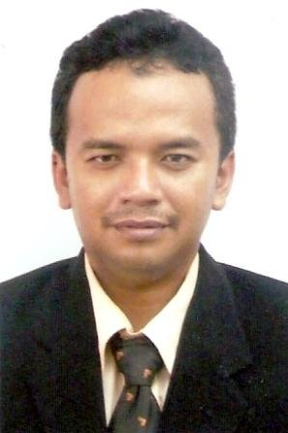**DENNY SETIAWAN,** born in Ciamis, West Java (1971), holds the position of Head of Group, Fixed and Land Mobile Services, Directorate of Spectrum Policy and Planning, Directorate General of Resources and Standard, Ministry of Communications and IT, The Republic of Indonesia.

Dr. Denny Setiawan graduated from Bandung Institute of Technology (ITB, 1994), majoring in Electronic Telecommunication Engineering, MSc of Telecommunication Engineering from University of Indonesia in 1999, and Doctor of Engineering from University of Indonesia in February 2013.

Since joining the Directorate General of Pos & Telecommunication in 1995, Dr. Setiawan has participated in many international conferences in Radio Communications, coordinating satellite orbits and frequencies bilaterally and internationally through ITU, and other regional and international telecommunication activities.

Dr. Setiawan is also an avid writer in telecommunication issues and has drafted the Master Plan and Map of Indonesian Frequency Allocation, including the digitalization and reallocation of TV and FM radios.

Presently Dr. Setiawan is formulating the strategic policy and planning of Mobile Broadband spectrum refarming and the related wireless broadband strategic policy and regulation.