CURRICULUM VITAE

For

Mr. PHUNG NGUYEN PHUONG

PERSONAL INFORMATION
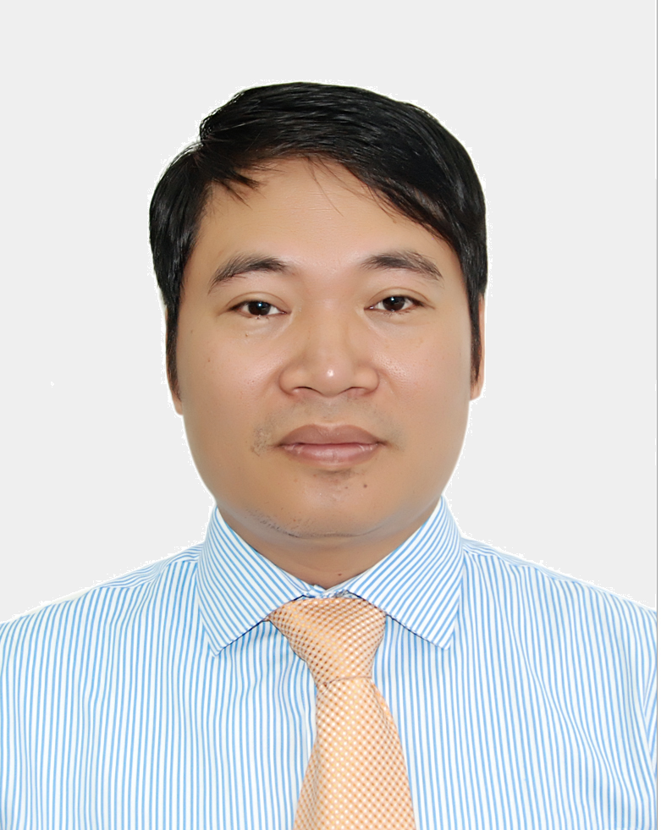
Full name : PHUNG NGUYEN PHUONG (Mr.)
Date of birth : 28 April 1972
Place of birth : Vinh Phuc – Viet Nam
Nationality : Vietnamese
Marital status : Married with a son and a daughter
Language : Vietnamese, English, French
Official address : 115 Tran Duy Hung, Cau Giay
Ha Noi - 10000, Viet Nam.
Tel. Number : +84-4-35564980
Fax. Number : +84-4-35564930
Email : phuongpn@rfd.gov.vn

Position
Director of International Cooperation and Frequency Coordination Division.
The Authority of Radio Frequency Management, MIC of S.R. of Viet Nam.

Educational Qualification
2001 | Master on Space Telecommunications, École nationale supérieure de l'aéronautique et de l'espace in France
1999 | Engineer in Manufacturing System Engineering, Asia Institute of Technology
1993 | Engineer in Electronics, Ha Noi University of Technology in Viet Nam
2004 | Course on Space Communication in Japan
1995 | Course on Radio Spectrum Monitoring and Measuring, Radio Frequency Spectrum Management and Spectrum Management in the Civil Sector in the United States Telecommunications Training Institute in the United States of America
Professional Experience
Mr. Phung Nguyen Phuong is an expert in radio frequency management.
Mr. Phuong has led the satellite coordination group and the preparatory group for cross-border frequency coordination meetings with neighboring countries. He also is responsible for bilateral meetings and international frequency registrations of Viet Nam.
He is also head of preparatory group for successfully hosting many international meetings of ITU-R, APT, ASEAN and ITU Regional in Viet Nam.
His extensive experience in Radiocommunication matters has been demonstrated by working with variety of organizations and international bodies namely ITU, ASEAN, APT, GSMA and other international conferences. Mr. Phuong has made many contributions and proposals to enhance the efficiency of the Radio Regulations, ITU procedures.

Working Process
2013 – Present | Director – International Cooperation and Frequency Coordination Division, Authority of Radio Frequency Management of Viet Nam (ARFM)
2009 – 2013 | Deputy Director – International Cooperation and Frequency Coordination Division, ARFM
2002 – 2008 | Official – Planning and Frequency Coordination Division, ARFM
1993 – 2000 | Expert – Technical Center, ARFM
International Activities
Mr. Phuong has actively participated as the role of key expert in many international meetings such as the World Radiocommunication Conferences, the Conference Preparatory Meetings for World Radiocommunication Conference (CPMs), Study group 4, Special committee on regulatory/procedural matters, APGs. He proposed a lot of contributions addressing conference agenda items on effective use of the radio frequency. Many of contributions resulted to the positive change in the Radio Regulations.
Mr. Phuong has been actively participating in Word Radiocomunication Conference (WRC) 2012, Conference Preparatory Meeting for WRC-12 (CPM12) and CPM15, ITU Plenipotentiary Conference 2011 (PP-11), ITU-R Working Parties 4A-4B, APT Preparatory Group for WRC-12, WRC-15 with many contributions to these meeting.
Participating and contributing to international activities:
- Chairman of Drafting Group in APT Conference Preparatory Group for WRC-15 Agenda item 7 on regulatory issues for satellite.
- Member of Viet Nam Delegation attending WRC-12, CPM11-2, CPM15-2, PP-11, ITU-R WP4A, 4B, SC.

Awards
- Medal awarded by the State President in 2013 and Certificates of Merit of Prime Minister in 2008, 2011 for achievements contributing to the social and economic development of Viet Nam.

