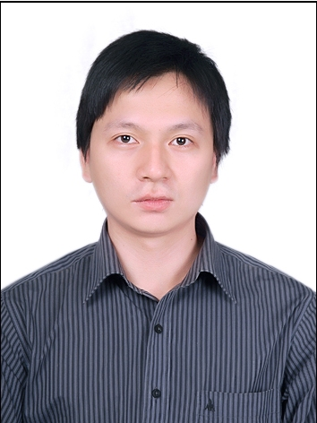
Name Pham Dang Truong
Company VNPT International, VNPT Corp,
Ministry of Information and Communications of the S.R. of Vietnam
Title Satellite Telecom Manager
Work Pham Dang Truong has been with VNPT International, VNPT Corp since 2006 and actively involved in various satellite communication aspects which include operating satellite earth station, operating VINASAT-1, 2 satellites, deploying VSAT systems, managing frequency coordination and regulatory issues of VINASATs satellites.

