 | 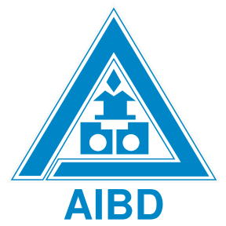 | 

Annex 2
ITU- AIBD- ABU Pre-Summit Workshop
“Enhancing Digital Terrestrial Television Broadcasting Transition Experience”
Kuala Lumpur, Malaysia
25 May 2015

PARTICIPANT’S INFORMATION

Venue
The ITU-AIBD-ABU Pre-Summit Workshop on “Enhancing Digital Terrestrial Television Broadcasting Transition Experience” will be held at Shangri-la Hotel, Kuala Lumpur, Malaysia on Monday, 25 May 2015. This Pre-Summit Workshop is being jointly organized by the ITU, ABU, and AIBD, with support of the Ministry of Internal Affairs and Communications, (MIC-Japan).

Registration
The Registration Desk will commence at 08.30 hrs on 25 May 2015 in front of the Meeting Room, Shangri-la Hotel. Please pre-register for ITU-AIBD-ABU Pre-Summit Workshop and Asia Media Summit (AMS) 2015 at http://www.aibd.org.my/tools/newdb/register_ams.php

Working language
The working language of the Pre-Summit Workshop and AMS 2015 will be in English.

Hotel Accommodation and Transport
Special rates for hotel accommodation have been arranged for all delegates during the Pre-Summit Workshop and AMS 2015 at:

Shangri-la Hotel

11 Jalan Sultan Ismail, Kuala Lumpur, 50250, Malaysia
Tel: +6-03-2032 2388 Fax: +6-03-2070 1514
www.shangri-la.com

Concorde Hotel Kuala Lumpur
2 Jalan Sultan Ismail,
50250 Kuala Lumpur, Malaysia
Tel : +6-03-2144 2200
http://kualalumpur.concordehotelsresorts.com

Single Room (Single Occupancy) RM 583 nett/night at Shangri-la Hotel

RM 379 nett/night at Concorde Hotel

(The above rates are inclusive of breakfast, service charge and Government tax)

Delegates are kindly requested to arrange the hotel booking directly with hotel by submitting the completed hotel reservation form Annex 4 to rabi@aibd.org.my

Delegates are advised to arrange their own transport from airport to hotel and vice versa.

Pre-Summit Workshop Website, Workshop Documents:

Related information about the pre-summit workshop and provisional workshop documents will be available at http://www.itu.int/en/ITU-D/Regional-Presence/AsiaPacific/Pages/events.aspx and http://www.aibd.org.my/ams.To support worldwide efforts in combating climate change, please be informed that this is a paperless workshop. Delegates are encouraged to carry their laptop computers for this workshop.

PCs and printers will be available at the Secretariat Room for printing necessary documents by delegates themselves.

- Immigration requirements
All participants entering Malaysia must possess valid passports or accepted travel documents and need to check visa requirements before entering the country. Please check the visa with the nearest Malaysian Embassy. For more information please visit the website http://www.kln.gov.my. Or http://www.imi.gov.my/index.php/ms/

- Health Requirements
ITU requests you all participants to ensure medical and travel insurance covering the whole period of the training course and overseas travel. Neither ITU, ABU, and AIBD will be able to meet any expenses relating to injury, accident or medical treatment of the participant.

- Transportation
Participants are recommended to arrive at KLIA International Airport, which is located about 70 kilometres from the centre of Kuala Lumpur. More detailed information can be found on the following web site http://www.klia.com.my

All participants are requested to make their own travel arrangements from airport and place of stay to the venue.

OTHER INFORMATION

ABOUT KUALA LUMPUR
Kuala Lumpur – KL to its friends – is more than just a capital city: it is a monument to Malaysian ingenuity and determination. From humble beginnings as a tin-mining shanty town, KL has evolved into a 21st-century metropolis, dominated by the tallest skyscrapers in Southeast Asia and flush with the proceeds of international trade and commerce. Over the years, KL has faced its share of challenges but nothing has succeeded in suppressing the determination of locals to make KL, and Malaysia, a leader among Asian tiger economies.
The marketing slogan for the Malaysian tourist board is ‘truly Asia’ and nowhere is this more true than in the capital. KL is every inch the Asian cyber-city: historic temples and mosques rub shoulders with space-age towers and shopping malls; traders’ stalls are piled high with pungent durians and locals sip cappuccino in wi-fi–enabled coffee hops or feast at bustling street side hawker stalls serving food from across the continent.
The most striking thing about KL from a visitor’s perspective is its remarkable cultural diversity. Ethnic Malays, Chinese prospectors, Indian migrants and British colonials all helped carve the city out of the virgin jungle, and each group has left its indelible mark on the capital. Eating, shopping and nightlife are undeniable highlights of any visit to KL, but don’t restrict yourself to the city – there are numerous parks and monuments dotted around Kuala Lumpur that make easy day trips for a break from the hustle and bustle.
Putrajaya is the new Administrative Centre of the Federal Government of Malaysia. It is situated within the Multimedia Super Coridor (MSC) and is about 30km from Kuala Lumpur. Putrajaya is a model township that has been constructed with detailed planning, innovative urban design and utmost concern for the preservation of the environment. Its beautifully landscaped roads and parks as well as modern buildings clearly reflect the duality of its theme – “Garden City, Intelligent City”.

CLIMATE

Kuala Lumpur has a tropical climate which means it gets plenty of sunshine all year round. Despite this, temperatures don’t usually become unbearably hot and generally range from about 22ºC to 33ºC. Humidity is quite high throughout the year and the average annual rainfall varies from 2,000mm-2,500mm.

LANGUAGE

Bahasa Malaysia is the official language but English is widely used, especially in the commercial sector. The ethnic groups also speak other language such as Mandarin and Tamil as well as Chinese dialects like Cantonese and Hokkien.

CLOTHING TIPS

Please bear in mind the Kuala Lumpur is very hot during the day. Generally, you will want to dress light and wear natural fibers that absorb perspiration.

CURRENCY AND EXCHANGE RATE

The Malaysian unit of currency is the Malaysian Ringgit (MYR). Notes are in denominations of RM1, 5, 10, 20, 50, 100 and the coins in use are 5, 10, 20 and 50 sen. US$1 is approximately equal to 3.6 Ringgit as per February 2015. There are moneychangers and banks for currency exchange. All commercial banks are authorized foreign exchange dealers. Major hotels, however, are only licensed to buy and accept foreign currencies in the form of notes and travelers cheques.

CREDIT CARDS

Major credit cards such as VISA, MasterCard, American Express and Diners Club are accepted by most business establishments.

TIPPING

Most hotels and restaurants levy a 10% service charge and 5% government sales taxes in their bills. Tipping is not customary.

AUTOMATIC TELLER MACHINE (ATM)

ATMs are available in most of the tourist spots in Kuala Lumpur. Among the banks with ATM providers are Citibank, CIMB Bank, HSBC, Bank of China, Maybank, Bank of America, and Public Bank. The said ATMs are also linked with VISA/CIRRUS.

ELECTRICITY

The standard supply is 220 volts, 50-60 Hz. The following electrical plugs are used in most hotels

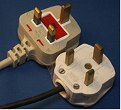

TIME ZONE

The standard Malaysia time is 8 hours ahead of GMT

TELECOMMUNICATION
Malaysia is linked nationally and internationally by telephone, facsimile, telegraph, telex and through internet. Most hotels provide International Direct Dial (IDD) telephone services. In cities and towns, public phones are available at high-traffic areas such as bus stations, shopping complexes and office buildings and are coins or phone card operated. Phone cards come in denominations of RM5, RM10, RM20 and RM 50 are available at news stands and petrol station. Prepaid Phone cards are sold virtually everywhere. Providers are: Maxis, Celcom and DiGi. Some of them offer good IDD rates starting from RM 0.10 to call abroad
To call overseas from within Malaysia dial 00 (Malaysia’s international access code) followed by the country code for the country you are calling, then the area code (dropping the 0) and the local number.

Calling Kuala Lumpur from overseas dial the international access code of the country you are in followed by 60 (country code for Malaysia), then 3 (area code for KL) and the local number.

FOOD

Malaysian cuisine is just like everything else Malaysian, a blend of different cultures which culminate into something unique, excellent and appealing to all. As with virtually every other country in the world, Malaysians tend to believe their food is the best. Various types of foods can easily be found in Kuala Lumpur, everything from Asian to Italian to Japanese to Arabian. From food stalls to 5 star hotels, you would be able to taste the various dishes of true Malaysian cooking, especially in Kuala Lumpur.

GETTING AROUND/TRANSPORTATION

With the availability of multiple modes of public transport, getting around Kuala Lumpur is not a problem. Although modern, Kuala Lumpur is not so large as to overwhelm the visitor. At any one time, there will be various interesting events going on, and also the places to go in Kuala Lumpur. The basic modes of travelling and moving around in Kuala Lumpur, are by taxi, bus or the KL Rail System.

TAXI
City taxis are metered. In Kuala Lumpur taxis are easily recognizable by their colours. Taxi fares are calculated according to meters. The flagged down fare is RM3.00 for the first two kilometers and 10 cent for every 200m there after (subject to change). A 50% surcharge is levied between midnight and 6.00 AM. Additional RM 2 is charged for: phone booking, 3rd adult passenger (max 4) and/or baggage stored in boot.

Pre-paid coupon system is used for taxi stands at KTM KL Station, KL Sentral & KLIA.

BUS

RapidKL, short for Rangkaian Pengangkutan Integrasi Deras Sdn Bhd, is a government-owned company which was formed in 2004 as part of the restructuring of the public transport system in Kuala Lumpur, Malaysia's capital.
RapidKL is the operator of Kuala Lumpur's two light rail transit (LRT) lines, the largest stage bus (regular or trunk bus route) and feeder bus service in Kuala Lumpur, and, as of November 2007, the single line of the KL Monorail and parts of the KLIA Transit route.

KL RAIL SYSTEM

There is a very efficient LRT system divided into three: Kelana Jaya Rail Line (formerly known as Putra Line), Ampang Rail Line (formerly known as Star LRT), and the Monorail. The train services run independently, but they have points where they have interchanges. The operating hours are from 6.00 am till 12.00 am.

Where to stop:
• Bukit Bintang (KL Monorail), for shopping in the Golden Triangle
• Bukit Nanas (KL Monorail), for KL-tower
• KLCC (Kelana Jaya Rail Line), for the Twin Towers and the Suria KLCC shopping mall
• KL Sentral (Kelana Jaya Rail Line /KL Monorail/KTM Kommuter), for intercity trains and the KLIA Ekspres to the airport
• Masjid Jamek (Kelana Jaya Rail Line /Star), for access to Chinatown and Little India, and interchange between Kelana Jaya Rail Line and Star
• Plaza Rakyat (Star), for Puduraya bus station

KUALA LUMPUR MAP

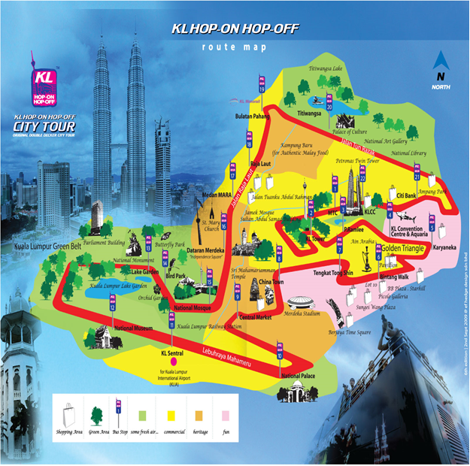

Contact

For any further information you may require or if you need a personal invitation letter or official document for your visa application, please contact:

ITU: Ms. Sireerat Bunnag
Tel: +662 575 0055 Fax: +662 575 3507
Email: sireerat.bunnag@itu.int

