 |  |  | 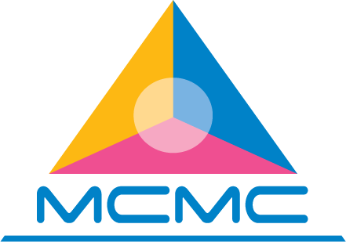
The General Meeting of International ICT Volunteers Networking 2015: Empowering Youth in ICT for Development
8 July 2015, Sutera Harbour Resort, Kota Kinabalu, Malaysia

-------------------------------------------------------------------------------------------------------------------------------------
In partnership with

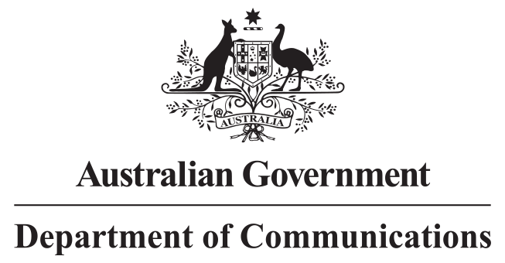 |  | 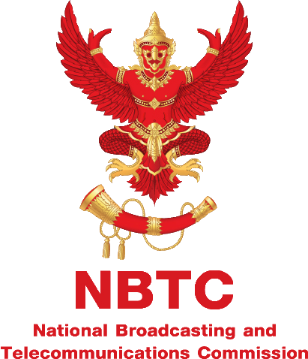

The first General Meeting International ICT Volunteers Networking 2015 with its theme of ‘Empowering youth in ICT for development’ is organised by the International Telecommunication Union (ITU) and hosted by the Malaysia Communications and Multimedia Commission (MCMC) in support of the Australian Government and the National Information Society Agency of the Republic of Korea (NIA).

The meeting will be held on 8th July 2015 at,

Sutera Harbour Resort, Kota Kinabalu, Malaysia
http://www.suteraharbour.com/

The meeting will be followed by the IIV-2015 Boot Camp which will be held from 9th to 11th July 2015 at the same venue.

Meeting Objectives
The General Meeting of International ICT Volunteers Networking 2015: Empowering youth in ICT for development is aimed to:
- Promote the International ICT Volunteers (IIV) programme;
- Identify and discuss about issues, challenges, and opportunities of the programme;
- Determine cooperation mechanism and partnership framework with multi-stakeholders including governments, authorities, and private sector;
- Discuss about ways forward and guidelines on establishing a national network of volunteers.

Participants
Expected participants include representatives of countries participating in the IIV 2015 programme i.e. Cambodia, Indonesia, Laos, Malaysia, Sri Lanka, Thailand, and Vietnam. Target participants also include representatives of partners and potential partners as well as stakeholders concerning empowering youth and ICT for development.

Expected Outcome
The meeting expected a common understanding among stakeholders and partners about the IIV programme and its coordination and cooperation frameworks. It is also expected that the meeting will bring to attention of participants especially potential partners benefits of the programme and hence partnerships and contributions from the stakeholders and partners would be made possible from this year onwards and on a sustainable manner.

More detail about the meeting, please visit:
http://www.itu.int/en/ITU-D/Regional-Presence/AsiaPacific/Pages/Events/2015/July-IIV-2015/home.aspx

Tentative Agenda
Wednesday 8 July 2015
08:30 – 09:30 | Registration
09:30 – 10:00 | Opening Session  - Welcome Remarks by Mr. Wisit Atipayakoon, IIV Programme Manager, ITU Regional Office for Asia and the Pacific  - Welcome Remarks by Dr. Myungha Hong, Director, Global IT Planning & Consulting Department, National Information Society Agency of the Republic of Korea (NIA)  - Opening Remarks by Dato’ Sri Dr Halim Shafie, Chairman of Malaysian Communications and Multimedia Commission (MCMC)
10:00 – 11:00 | Introduction  - Overview of International ICT Volunteers (IIV)  Mr. Wisit Atipayakoon, IIV Programme Manager, ITU Regional Office for Asia and the Pacific  - Overview of Korea IT Volunteers (KIV) by Dr. Myungha Hong, Director, Global IT Planning & Consulting Department, National Information Society Agency of the Republic of Korea (NIA)  - Overview of NBTC-ITU Volunteers (NIV)  General Sukit Khamasundara, Commissioner, National Broadcasting and Telecommunications Commission of Thailand (NBTC)
11:00 – 11:20 | Tea break sponsored by MCMC
11:20 – 12:40 | Panel Discussion – country perspective and experience  Moderator: Mr. Wisit Atipayakoon, IIV Programme Manager, ITU Regional Office for Asia and the Pacific  Panellists:  - Mr. Noy Shoung, Vice President, National Institute of Posts, Telecoms and ICT of Cambodia (NIPTICT)  - Mrs. Septriana Tangkary, Director of ICT Empowerment, Ministry of Communication and Information Technology (MCIT), Indonesia  - Mr. Chanthaviphone Chansylilath, Head of Planning Division, Ministry of Posts and Telecommunications (MPT), Laos PDR  - Mr. Toh Swee Hoe, Chief Officer, Digital Empowerment Sector, Malaysian Communications and Multimedia Commission (MCMC)  - Mr. Wares Borvonsin, Executive Director, Universal Service Obligation Bureau, National Broadcasting and Telecommunications Commission (NBTC), Thailand  - Mr. Quyen Nguyen Quy, Head of Multilateral International Cooperation Section, International Cooperation Department, Ministry of Information and Communications (MIC), Vietnam
12:40 – 14:00 | Lunch break sponsored by MCMC
14:00 – 16:00 | - Presentation by Mr. Anshul Sonak, Regional Director – Innovation & Learning, Intel For Good – APJ  Panel Discussion – cooperation mechanism, partnerships, and ways forward  Moderator: Mr. Wisit Atipayakoon, IIV Programme Manager, ITU Regional Office for Asia and the Pacific  Panellists:  - Cambodia, Indonesia, Laos PDR, Malaysia, Thailand and Vietnam
16:00 – 16:20 | Conclusion and Closing
16:20 | Refreshment sponsored by MCMC
19:30 | Dinner with Delegates at Kg Nelayan Seafood Restaurant – sponsored by MCMC

