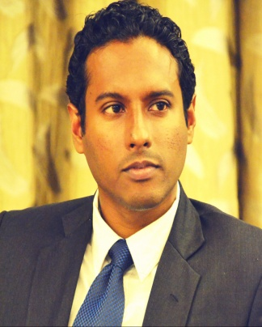

Biography –

“Highly versatile telecommunications and IT professional with 10+ years of experience spanning across full sphere of business including Prepaid, Data services,

Charging Systems, CS Core, PS Core, VAS, ISP, IT Systems, Product management and BCP. Who also possess a well-balanced techno-commercial academic and professional background with hands-on experience throughout the value chain of a technology business.”

**Udaka Kappagoda,** ACMA, GCMA, BSc (1st Class Hons) Engineering, MBA, MSc. International Business.

**Manager – IN & Data Services, Bharti Airtel Lanka (Pvt) Ltd**.