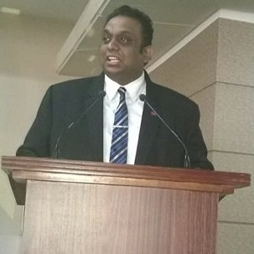
Thareendra Kalpage
Enterprise Account Manager
Government & Defense, Sri Lanka & Maldives region
Microsoft Corporation
a-tharek@microsoft.com

Thareendra Kalpage is an Experienced Business Leader and Value Creator through Business Solutions, Business Intelligence, Analytics and Insights for Microsoft in Government, Defense customers.

Based in Colombo, Thareendra is responsible for strategically engaging the Public Sector market, defining Microsoft’s strategy and vision, and assisting Customers in transforming their organizations’ mission-critical operations in response to emerging threats and challenges.

Thareendra joined the Sri Lanka team in 2010. Prior to his current role, Thareendra was a Public Sector Manager for leading Telecom and Constructions Services Company , where his responsibilities included selling and managing consulting services and turnkey solutions for the Sri Lanka government sector as well as setting up and leading a Services team for Middle East & Africa (MEA) specializing in Telecom and Construction domain . Thareendra Joined Microsoft Public Sector Team in 2010 as an Account Manager for Public Sector, where he drove Technology adoption programs in many government organizations and led the Microsoft Account Teams for major win.

Thareendra is known as the face of Microsoft to many government organizations and played instrumental role with many large government Information Technology Projects. Thareendra is highly respected and considered as trusted adviser by Government Ministries and Departments where he is leading the Technology conversation for Microsoft.

Thareendra began his career as an Information Technology Executive with D .Samson Group, which is one of the largest group of companies in Sri Lanka where he spent three years with. He later spent 8 years in various research and development, consultancy and business development roles at local & international companies.

.

