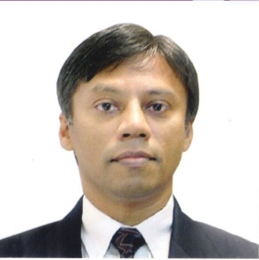**Nimal Ratnayake**

Nimal Ratnayake obtained his Bachelors degree from University of Peradeniya and Masters and Doctorate from Rennselaer Polytechnic Institute in Troy, New York. He has been instrumental in developing networks in the academic sector and the government sector in Sri Lanka.

He is a pioneer in the open source software movement in Sri Lanka. He has also conducted numerous training programs related to open source software, networking, virtualization and cloud infrastructure.