 | 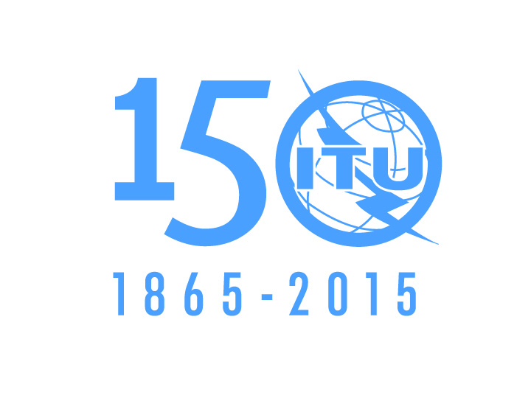 | 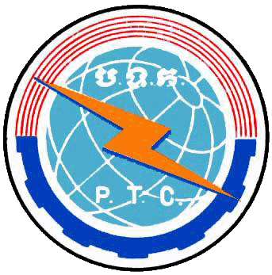

ITU-ASEAN Forum on Over the Top (OTT) Services:
Business, Policy and Regulatory Trends

08-09 December 2015, Phnom Penh Cambodia

PROVISIONAL PROGRAM

DAY 1: 08 December

08:30 - 09:00 | Registration
Opening Session
09:00 - 09:10 | Welcome Remarks  International Telecommunication Union
09:10 - 09:30 | Opening Remarks  HE Mr. Prak Sokhonn, Minister of Posts and Telecommunication, Cambodia
09:30 – 10:00 | Group Photo and Coffee Break
10:00 - 11:15 | Session 1: Setting the Scene  Objective: The Session provides an overview of OTT: its basic concepts, evolution and current status to pave the way and facilitate interactive discussions in the following sessions of the Forum  Session Chairman: Ms. Aurora A. Rubio, Head, ITU Area Office for South East Asia  Topics:  - OTT Concepts and Terminology  - Evolution of OTT Technology and Services  - A closer look between traditional telecommunications and OTT businesses  - The many forms and types of OTT and its providers  Speakers:  - Mr. Guillaume Mascot, APAC Public Affairs Director, Alacatel-Lucent Asia Pacific  - HE TOL Gnak, Director General of Posts and Telecommunications, Ministry of Posts and Telecommunications, Cambodia  - Ministry of Information, Cambodia (TBA)  - Expert from the Philippines (TBC) (10 min)  - Q & A: 15 min
11:15 - 12:30 | Session 2: Key Drivers and Issues  Objective: The world is going digital very fast. The convergence of many different technologies is pushing down the half-life of an average business competency from 30 years to 5 years. Data consumption is exploding and consumer demand for OTT services is rapidly growing as consumers want more of, and perceive large benefits from, these services. Consumers expect to be able to access legal content, applications and services and want information about their subscriptions. Such services create demand for broadband access and services but also are requiring network operators to seek new business models and arrangements, particularly in developing countries. The Session will attempt to provide different views and experiences on the key drivers to high consumer demand for OTT services as well as general issues and challenges faced by telecommunication network service providers.  Session Chairman: H.E Dr. KHOV Makara, Under-Secretary of State, Ministry of Posts and Telecommunications, Cambodia  Topics:  - The Promises of OTT  - Factors pushing a market towards OTT alternatives  - OTT core business models  - Implications for traditional telcos  Speakers:  - Mr. Pedro Seixas, ITU Consultant  - Expert from SMART Axiata Co., Ltd. (TELCO’s views)  - Mr. Nguyen Quy Quyen Head of Multilateral Cooperation Section, International Cooperation Department, Ministry of Information and Communication, VietNam : Country Report
12:30 – 14:00 | Lunch Break
14:00 – 15:30 | Special Session on Transitioning from IPv4 to IPv6  Objective: With the massive deployment of Internet-related resources worldwide and the integration of IP-enabled consumer devices connected directly to the network, the issue of the depletion of IPv4 addresses is becoming pertinent. This Session aims to establish the need to effectively plan and deploy IPv6 to address among others, the current shortage of public IPv4 addresses.  Session Chairman: HE TOL Gnak, Director General of Posts and Telecommunications, Ministry of Posts and Telecommunications, Cambodia (TBC)  Topics:  - IPv4 Status  - Why IPv6? The IPv6 Solution  - IPv6 Deployment challenges and opportunities  - IPv6 Interoperability, Mobility and Security  - Technical and Policy Aspects  - Combined Use of IPv4 and IPv6  Speakers:  - Mr. Pablo Hinojosa, Director for Strategic Engagement, APNIC  - Mr. JIA Rong, Head, Strategy and Initiatives for the Asia-Pacific Region, ICANN  - Mr. Sun Rapid, Director, Department of R&D, NIPTIC  - Telcotech (TBC)
15:30 – 15:45 | Coffee Break
15:45 – 17:00 | Session 3: OTT and its multi-faceted impacts  Objective: It is generally accepted that, in future, if not already happening at present, the provision of OTT players will have multi-faceted impacts. The Session will look at how OTT impacts on several areas such as competition, network infrastructure and regulation among others and how they are being addressed by concerned players.  Session Chairman: H.E. Mr. MOA Chakrya, Chairman, Telecommunication Regulator of Cambodia (TRC)  Topics:  - On consumers  - On regulation  - On competition  - On network Infrastructure  - On others  Speakers:  - Mr. Guillaume Mascot, APAC Public Affairs Director, Alacatel-Lucent Asia Pacific  - Mr. Taufik Hasan, Commissioner, Telecommunication Regulation Body of Indonesia (BRTI)  - Expert from EZECOM(TBC)
19:00 – 21:30 | Gala Dinner to be hosted MPTC
End of Day 1
Day 2: 09 Dec 2015
09:00 – 10:15 | Session 4: Country Challenges and Opportunities  Objective: The Session will promote information and experience exchange on countries’ initiatives/plans on OTT services.  Session Chairman: H.E CHUN Vat, Under-Secretary of State, Ministry of Posts and Telecommunications, Cambodia  Topics:  - ASEAN Report on OTT  - India’s Consultation Paper on Regulatory Framework for OTT Services (TBC)  - Experiences from ASEAN countries  - Mr. NEANG Mao, Deputy Director of ICT, Ministry of Posts and Telecommunications, Cambodia  - Mr. Muhammad Razali Anuar, Head of the Strategy and Policy Initiatives Department (SPID), MCMC
10:15 – 10:30 | Coffee Break
10:30 – 11:45 | Session 5: Building Synergies between OTT players and ICT network operators  Objective: There are opportunities to build synergies between OTT players and ICT network operators. The Session will scope synergy possibilities among concerned players.  Session Chairman: H.E CHUN Vat, Under-Secretary of State, Ministry of Posts and Telecommunications, Cambodia  Topics:  - Exploring win-win scenarios among players in the digital value chain  - Potential Operators’ Responses to OTT  - Need for regulatory intervention?  - Case Studies  Speakers:  - Mr. Pedro Seixas, ITU Expert  - Expert from TELCO in Cambodia (TBC)  - Mr. Chanthaviphone Kheuapkhamvone, Head Division of Planning, Department of Planning and Cooperation, Ministry of Posts and Telecommunications, Lao PDR : Country Report
10:30 – 12:00 | Panel Discussion: Business and regulatory solutions and strategies that will promote sustainability of the ICT ecosystem  Objective: Massive network investments are needed to cope with demand in wireless, wireline or backhaul networks in the new telecommunication/ICT ecosystem which has arrived. However, the need for investment comes at a time of telcos’ perceived degradation of service and ensuing loss of revenues, bandwidth-hungry Over-The-Top (OTT) players and outdated data connection agreements, leaving the industry reluctant to invest in network upgrades. It is no longer possible to meet the growing needs through approaches strictly confined to specific vertical sectors or geography set by existing legislations, regulations and practices but requires a much holistic and agile approach. The Panel Discussion aims to explore new innovative business and regulatory strategies that will promote sustainability of the whole ICT ecosystem.  Paper Presentation: Mr. Pedro Seixas, ITU Expert  Moderator: H.E Dr. KHOV Makara, Under-Secretary of State, Ministry of Posts and Telecommunications, Cambodia  Panellists:  - H.E. Mr. MOA Chakrya, Chairman, Telecommunication Regulator of Cambodia (TRC)  - Mr. Guillaume Mascot, APAC Public Affairs Director, Alcatel-Lucent Asia Pacific  - TRAI (TBC)  - Mr. Taufik Hasan, Commissioner, Telecommunication Regulation Body of Indonesia (BRTI)
12:00 – 12:30 | Chairmen’s Session: Synopsis of Sessions, Recommendations and Way Forward  Moderator: HE KHOV Makara, Undersecretary of State, Ministry of Posts and Telecommunications, Cambodia
12:30 – 14:00 | Lunch break
14:00 – 15:00 | Special Session: Summary Report on WRC-15  Speakers:  - Dr. CHEANG Sophak, Deputy Director General, MPTC  - Dr. KY Leng, Deputy Director General, MPTC  - Mr. SEA Nareth, Deputy Head of TRC Secretariat | Information Exchange and Networking for Foreign Guests
15:00 – 15:30 | Closing Session  By HE KAN Chanmeta, Secretary of State, MPTC
End of the Forum

