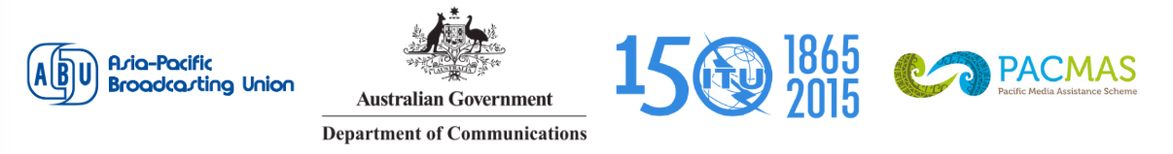

PACIFIC MEDIA PARTNERSHIP CONFERENCE 2015
Partnering for Broadcasting
25-27 August 2015, Apia, Samoa

PARTICIPANT’S INFORMATION

Venue
The Pacific Media Partnership Conference 2015 with the theme Partnering for Broadcasting will be held at the Government Conference Centre, Beach Road, TATTE Building, Apia, Samoa.

Registration
The Registration Desk will commence at 08.30 hrs on 25 August 2015.

Please pre-register online at http://www.abu.org.my/Event-_-PMPC2015.aspx

Working language
The working language of the Pacific Media Partnership Conference 2015 will be in English.

Hotel Accommodation and Transport
Special rates for hotel accommodation have been arranged for all delegates during the Pacific Media Partnership Conference 2015 at:

Tanoa Tusitala Hotel (Conference Venue)
http://www.tanoatusitala.com

Travellers Point Hotel Samoa
http://www.travellerspointhotel.com

Malifa Lodge - Malifa, Apia Samoa
Telephone: +865 655 655
Fax: +685 655 755
Email: info@malifalodge.ws

Single Room (Single Occupancy)

$190 nett/night at Travellers Point Hotel Samoa

Delegates are kindly requested to arrange the hotel booking directly with hotel.

Delegates are advised to arrange their own transport from airport to hotel and vice versa.

Pre-Conference Workshop:
Related information about the pre-conference workshop will be updated on the website (http://www.abu.org.my/Event-_-PMPC2015.aspx).

- Immigration requirements
Visas are issued upon arrival at the airport, at no cost. Please note if you travel through Australia and NZ, you will need to have transit visas for those countries. If you travel through Fiji, you do not require.

- Health Requirements
Please ensure that you have medical and travel insurance covering the whole period of the event as the organizers will not be able to meet any expenses relating to injury, accident or medical treatment of the participant.

8. Climate
Samoa enjoys an ideal Pacific Tropical climate. Visitors to Samoa should bring lightweight summer clothing. Visitors are requested not to wear bathing suits in Apia town or in the villages, only in hotel swimming pools and at beaches. NO topless swimming for women is allowed anywhere in Samoa.

9. Electricity
Runs on 240 volts, 50Hz. 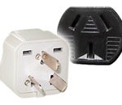

10. Currency and Banking Facilities
Samoan Tala is the local currency and banks accept NZD, AUD,USD and FJD
Major credit cards are welcomed by most hotels, and car rental companies.

11. Airport Tax
Please note there is a departure tax of SAT65.00 per person payable at Faleolo airport.

12. Health Insurance
It is important to have appropriate health insurance in the event of an accident or unforeseen circumstance. Full medical services are available at the main hospital in Apia town, but it is not possible to buy health insurance in Samoa.

13. Official Languages
Official texts are in English and Samoan languages. Both languages are also widely spoken by the Samoa population.

14. Religion
The main religious denominations in Samoa are of Christian faith – Methodist, Catholic, Assembly of God, Nazarene, Protestant, Anglican Seventh Day Adventist, Bahai, Latter Day Saints and Jehovah’s Witness.

Contact

For any further information you may require or if you need a personal invitation letter or official document for your visa application, please contact:

ITU: Ms. Sireerat Bunnag
Tel: +662 575 0055 Fax: +662 575 3507
Email: sireerat.bunnag@itu.int
&
ABU : Ms. Geraldine Peters
Tel: +6 03 2282 3108 Fax: +6 03 2282 5292
Email: geraldine@abu.org.my

