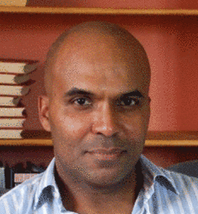

Theo is the founder of SocialEco and is dedicated to developing transformational Internet and mobile based solutions and business models that empower people and facilitate the emergence of a fairer, more connected and sustainable world.

Theo was involved in the introduction of pioneering Unified Communications technologies into Europe for Vivao Plc, Technology and Marketing consultancy for telecoms companies Transnet, Euphony and Stanhope, and while with Hanson Cooke publishing, facilitating international Public-Private Partnerships at Board and Ministerial level for the Commonwealth Secretariat.

Theo received a United Nations Award for the contribution of MDG Game to the Millennium Development Goals. Working closely with the United Nations who provided official data and statistical information, Theo designed MDG Game, a fun and easy way to learn about the MDGs. MDG Game is recognized as the first and only educational online game on the MDGs that incorporated official United Nations statistical data and was launched by UN DESA at the Shanghai World Expo 2012.

A former Decathlon champion, Theo enjoys running and swimming to keep fit, connecting with like minds and collaborating on disruptive technologies that realize global human potential.