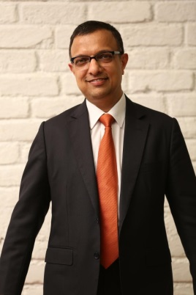

Dr. Nachiket Mor has a Post Graduate Diploma in Management from the Indian Institute of Management at Ahmedabad and an MA and a PhD in Economics from the University of Pennsylvania. He is Board Chair of CARE India and a member of the Boards of Reserve Bank of India, National Bank for Agriculture and Rural Development, Micro Units Development and Refinance Agency, and CRISIL. He is also a member of the Health Commission for the State of Himachal Pradesh in India, and the Task Force on Global Health at the Institute of Medicine in Washington DC. He worked with ICICI from 1987 to 2007 and was a member of its Board of Directors from 2001 to 2007. From 2007 to 2011, he served as the founding President of ICICI Foundation.