**Speaker Profile – Xiaodong Wang**

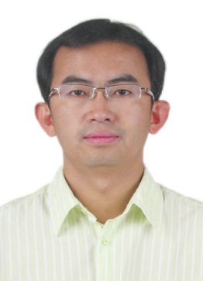

Senior Engineer

The State Radio Monitoring Center

Telephone: +86 010 68009090

Cell phone: +86 13693207293

Email: wxd@srrc.org.cn

Department: Spectrum Engineer Department

**Biography**

Mr. Xiaodong Wang received the Bachelor degree in Communication Engineering in 2001 from the Department of Electronic Engineering, Beijing Institute of Technology, China.

From 2001, as an engineer of the state radio monitoring center, MIIT, he mainly engaged in the field of national spectrum planning and assignment, electromagnetic compatibility analysis on radio communication systems and international coordination of satellite networks and terrestrial services.

Over the past few year, he participated in a series of communication security tasks in major events such as Beijing Olympic Games and military parade of sixties National day, and accumulated a wealth of experience in frequency assignment and spectrum monitoring.

Now, he is the deputy chairman of the working group of Satellite and Microwave Communication of WP Radio Communications in China Communications Standards Association (CCSA).