**Speaker Profile – Liang Chang**

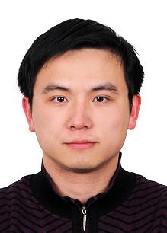

The State Radio Monitoring Center,

Telephone: +86-10-61255058 (office)

Mobile phone: +86-13521315545

E-mail: changliang @srrc.org.cn cl0516@hotmail.com or changliang@srrc.org.cn

**Biography**

Dr. Liang Chang received his B.S. and Ph.D. degrees in 2003 and 2008, respectively, both from the department of Electrical Engineering, Tsinghua University. Since 2008, he has been with the State Radio Monitoring Center (SRMC) as an engineer and then a senior engineer. From May 2014 to May 2015, he was a visiting scholar at Information Transmission and Processing Lab (ITP), Georgia Institute of Technology, Atlanta, U.S.A.

His general research interests include statistical signal processing and spectrum monitoring techniques, with emphasis on signal identification, localization and its application to spectrum monitoring. In these areas, he has published more than 20 refereed papers in addition to 2 patents. He also submitted 3 contributions to ITU-R WP1C and participated the drafting and revision of recommendation “Technical identification of digital signals” and report ”Spectrum monitoring evolution”.