**Speaker Profile – Junfeng Wang**

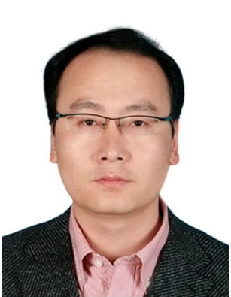

Senior engineer

The State Radio Monitoring Center

Telephone: +86 10 57996168

Cell phone: +86 13683233028

Email: wangjf@srrc.org.cn

Department: State Radio_monitoring_center Testing Center (SRTC)

**Biography**

Mr. Junfeng Wang, senior engineer, the deputy director general of State Radio_monitoring_center Testing Center(SRTC), with a Master degree major in electronic & communication technology engineering. He is the member of Wireless and Mobile Communications Committee of China Institute of Communications(CIC), member of radio spectrum monitoring and testing committee of China Radio Association(CRA), deputy chair of working Group 3 of Wireless Technical Committee of China Communications Standards Association(CCSA). Mr. Junfeng Wang Graduated from Beijing Institute of Technology(BIT) in 2001, majoring in information engineering, bachelor degree. He received Master degree of Electronic and Telecommunication Engineering in 2008 from Beijing University of Posts and Telecommunications, Beijing, China.

He started his career August 2001, and has been engaged in radio technology and spectrum management, including radio equipment management research, test lab operation & management, radio frequency (RF), electromagnetic compatibility (EMC) and mobile communication tech terminal conformance testing research. Be familiar with variety of wireless technology standards and domestic and international radio regulations.

He has been committed in several high tech research project which cover RFID, LTE, Digital PMR, and Internet of Things (IOT) technologies. As the main editor, he has accomplished 3 national standards, 4 industrial standards, 2 books, and more than 20 papers in domestic and international journals.