Speaker Profile – Jiaxin Ding
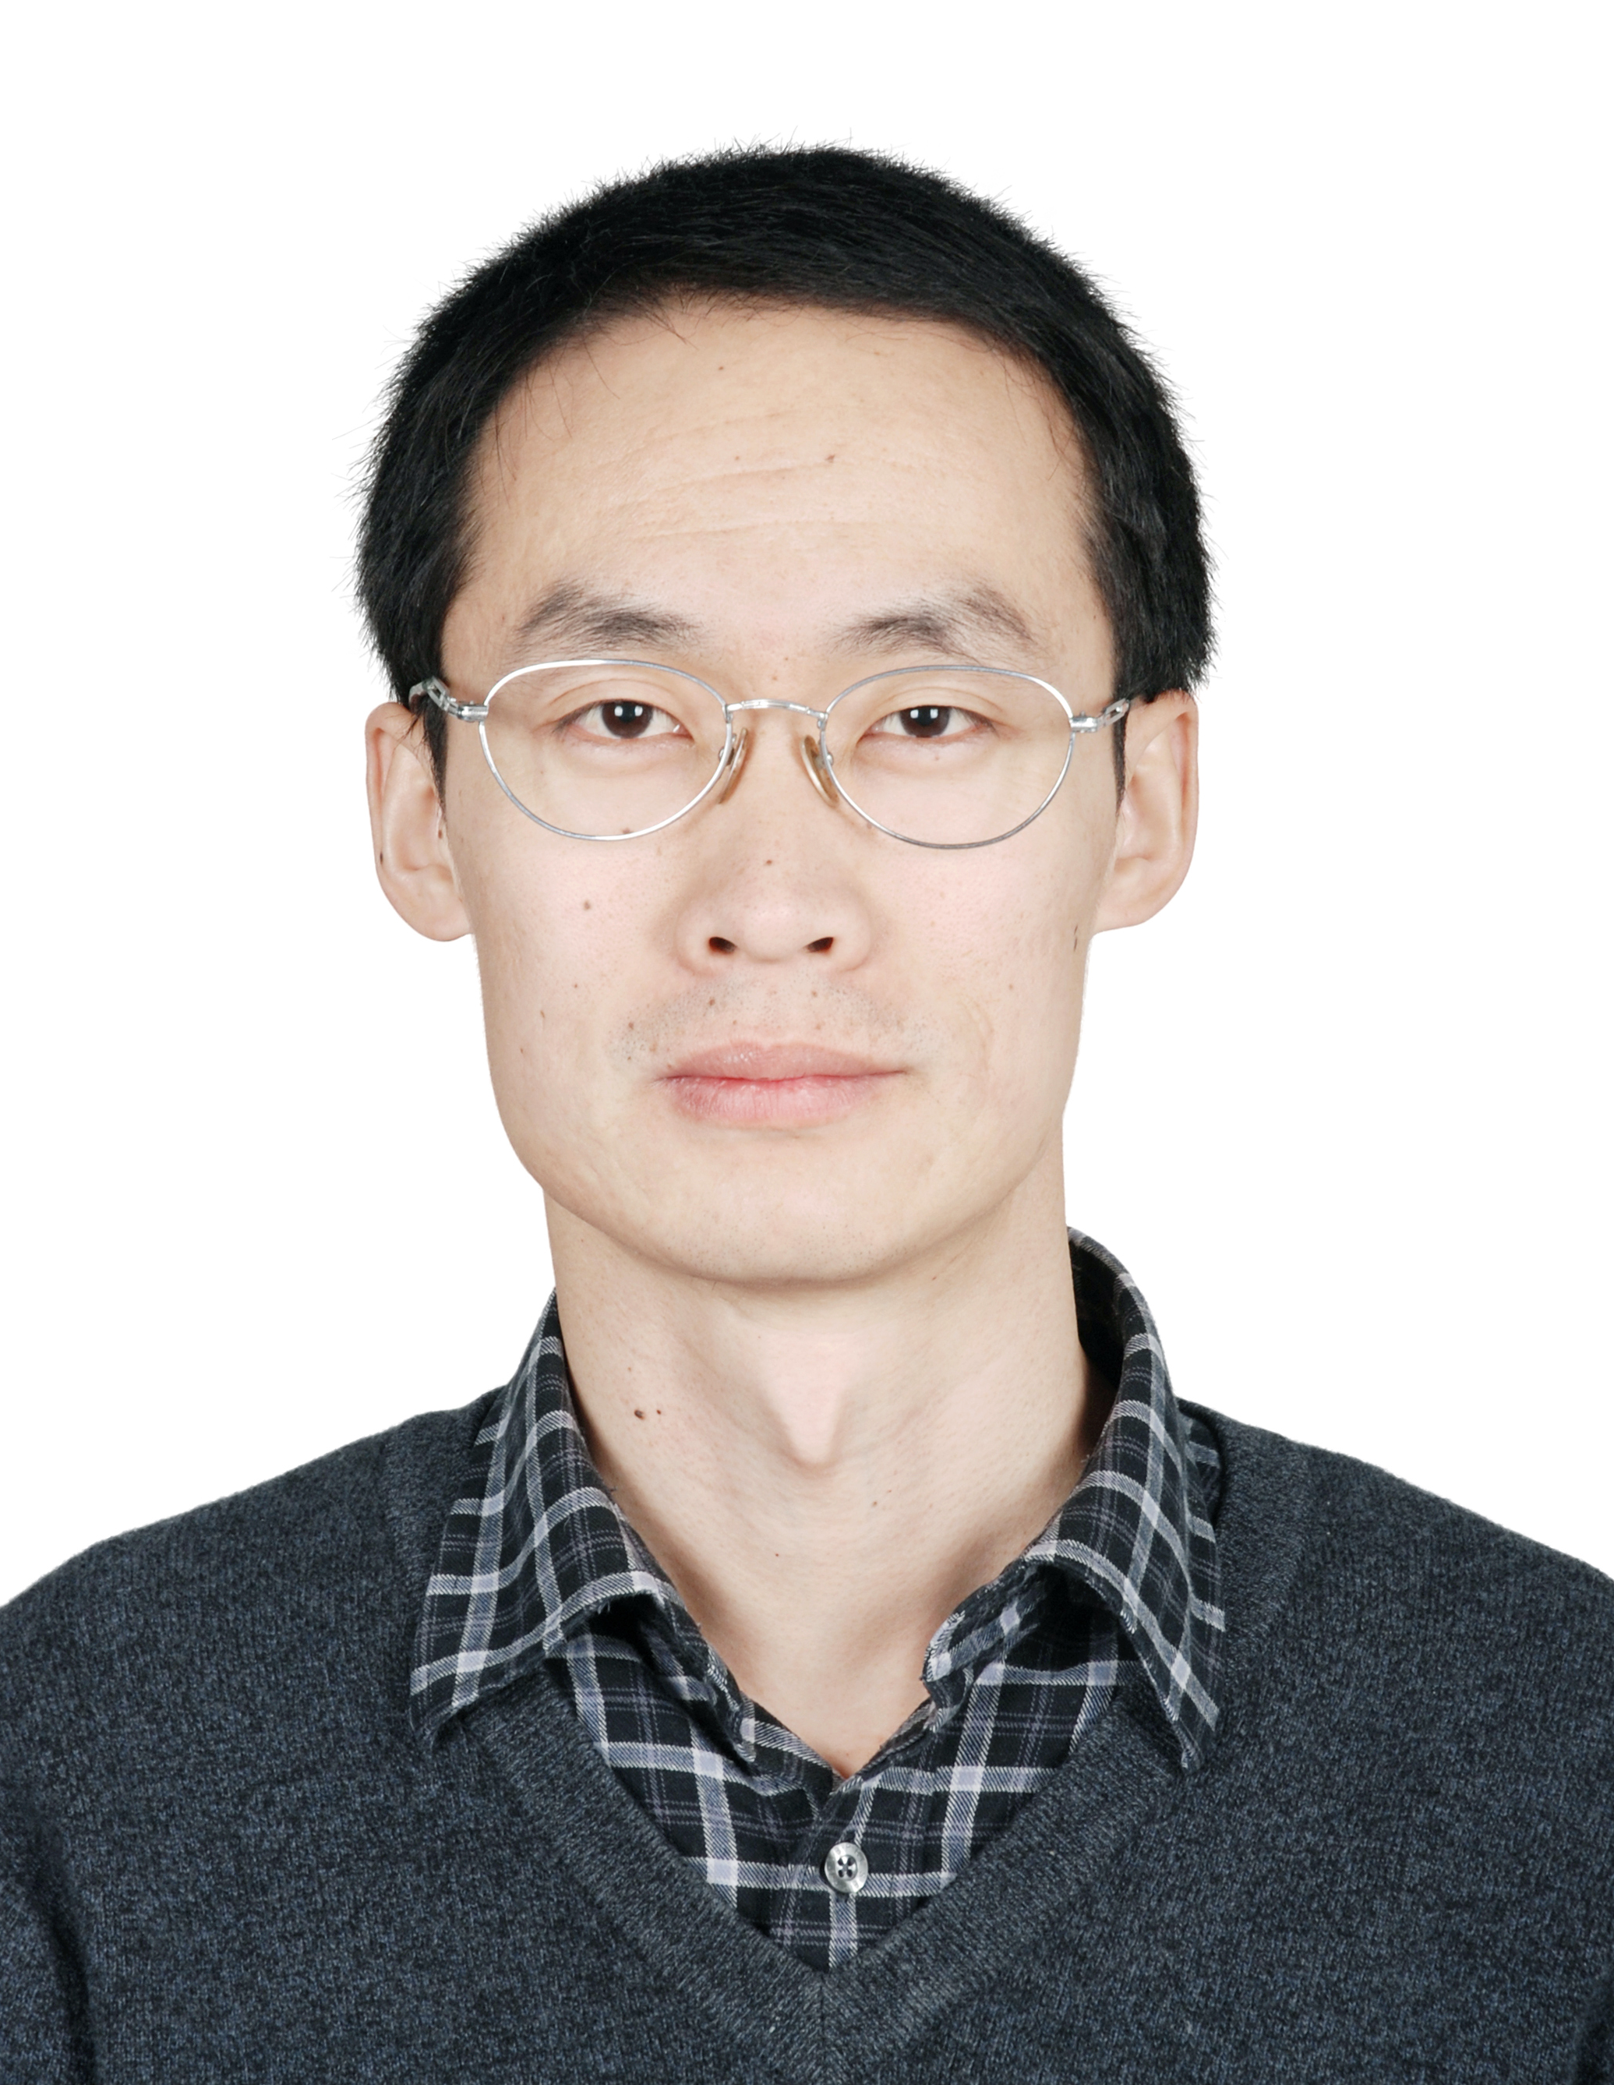
Deputy Director of the Spectrum Engineering Department
The State Radio Monitoring Center

Telephone: +86 010 68009084
Cell phone: +86 13651203564
Email: dingjiaxin@srrc.org.cn
Department: Spectrum Engineering

Biography
Dr. Jiaxin Ding received his M.S. degree in Electrical Engineering in 2000 from Nanjing Institute of Posts and Telecommunications, Nanjing, China. He received his Ph. D. degree in Electrical Engineering in 2003 from Beijing University of Posts and Telecommunications, Beijing, China. From April 2010 to April 2011, he was a visiting scholar in the Department of Electrical Engineering at Stanford University, Palo Alto, CA, U.S.A.

He devoted to radio monitoring and spectrum management since 2004. He worked in Beijing Radio Monitoring Station from 2004 to 2010, and he was the deputy director form July 2006 to March 2010. Then, he works in Spectrum Engineering Department. He is now the deputy director of the Spectrum Engineering Department.

His research has covered a wide range of topics in Radio Management and Radio Monitoring. He has participated in several major projects and published over 10 papers in famous journals and the important national academic conferences. Additionally, he translated the book, Essentials of modern spectrum management by Martin Cave, Cambridge University Press 2007, into Chinese and published it.

Dr. Jiaxin Ding was the tutor of the radio monitoring and spectrum management training for Asia and the Pacific organized by the ITU, May 2005 and May 2006. He is the Chairman of CPM15-2 6d-AI 9.2 and Aeronautical and Maritime task group of AWG since the AWG-12 meeting. He won special government allowance from the State Council in 2014.

