**Speaker Profile – Guocheng Chen**

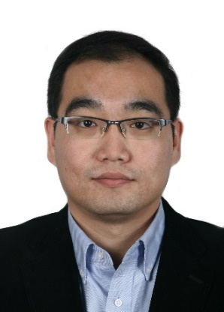

Engineer

The State Radio Monitoring Center

Telephone: +86 010 57996080

Cell phone: +86 13911990024

Email: chenguocheng@srtc.org.cn

Department: The State Radio_ monitoring_ center Testing Center (SRTC)

**Biography**

Mr. Guocheng Chen received Bachelor degree of Electronic Information Engineering in 2006 from China Agriculture University. He received Master degree of Electronic and Telecommunication Engineering in 2012 from Beijing University of Posts and Telecommunications.

He became an engineer of the State Radio_monitoring_center Testing Center since 2006. He became an expert of Communication branch of China Institute of Electronics in 2014.

Now he is mainly focus on for Type approval testing for different kinds of radio equipments, such as 2G/3G/4G base station, private mobile radio, radar and navigation, broadcasting station, wireless access system; also on testing methods research and automatic testing system development.