**Speaker Profile – Anping Li**

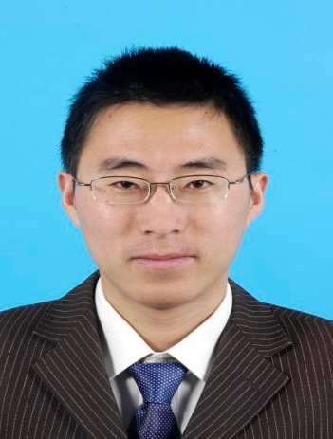

Chief Engineer of Institute of Radio spectrum technology

The State Radio Monitoring Center

Telephone: +86 010 68009211

Cell phone: +86 13488795253

Email: lianping@srrc.org.cn

Department: Institute of Radio spectrum technology

**Biography**

Mr. Anping Li received the Master degree in Electromagnetic and Microwave technology in 2008 from Beijing University of Post and Telecommunication, Beijing, 2008, China.

He became a radio monitoring engineer of State Radio Monitoring Center, Beijing, China, in 2008.

His research interests lie in the satellite monitoring and innovational technology of radio monitoring. In recent five years he has been involved in more than ten main interference finding. Then he turned to research and developed the radio monitoring products in 2013. Especially he devoted to radio monitoring product research based on TDOA since 2012.

* 2008 Olympic Games radio security guard.
* Radio security guard to 60th national day anniversary.
* An important TV program signal quality test in North China.
* Key interference finding in satellite and radar.
* Radio Monitoring Technology training 20+ times nationwide;