
The First Pacific Islands Capacity Building Workshop on Child Online Protection and Commonwealth National Cybersecurity Framework Regional Workshop
22-24 September 2014
Port Vila, Vanuatu

Supported by
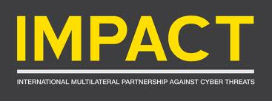

REGISTRATION FORM
To be returned to Mr. Wisit Atipayakoon at wisit.atipayakoon@itu.int
before 25 August 2014

Name :
MR./MRS./MS./DR./PROF. FIRSTNAME MIDDLE NAME LASTNAME
Administration/Organisation:

Present Post (Job Title) :

Division/Department :

Contact Address :

City / State : |  |  | Zip Code : |  |  |  |  | Country :
Phone No : |  |  |  | Fax No :
Email address :
Arrival / Departure Information
Arrival Date: | Arrival Time: |  |  |  |  | Arrival Flight:
Departure Date: | Departure Time: |  |  |  |  | Departure Flight:
Hotel Reservation
[please indicate a hotel below] |  | Check-in Date: |  |  |  |  | Check-out Date:
Date : |  |  |  |  | Signature :

