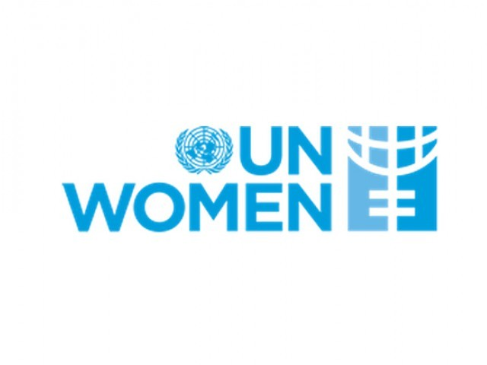



WOMEN WITH THE WAVE High Level Forum Series:
Turning the Tide for the Pacific, Women’s Economic Empowerment through Information and Communication Technology (ICT) and Media, Nadi, Fiji
17 November 2014

REGISTRATION FORM
To be returned to Mr. Andreas Christiono at andreas.christiono@itu.int
before 31 October 2014

Name :
MR./MRS./MS./DR./PROF. FIRSTNAME MIDDLE NAME LASTNAME
Administration/Organisation:

Present Post (Job Title) :

Division/Department :

Contact Address :

City / State : |  |  | Zip Code : |  |  |  |  | Country :
Phone No : |  |  |  | Fax No :
Email address :
Arrival / Departure Information
Arrival Date: | Arrival Time: |  |  |  |  | Arrival Flight:
Departure Date: | Departure Time: |  |  |  |  | Departure Flight:
Hotel Reservation
☐ |  | Check-in Date: |  |  |  |  | Check-out Date:
Date : |  |  |  |  | Signature :

