
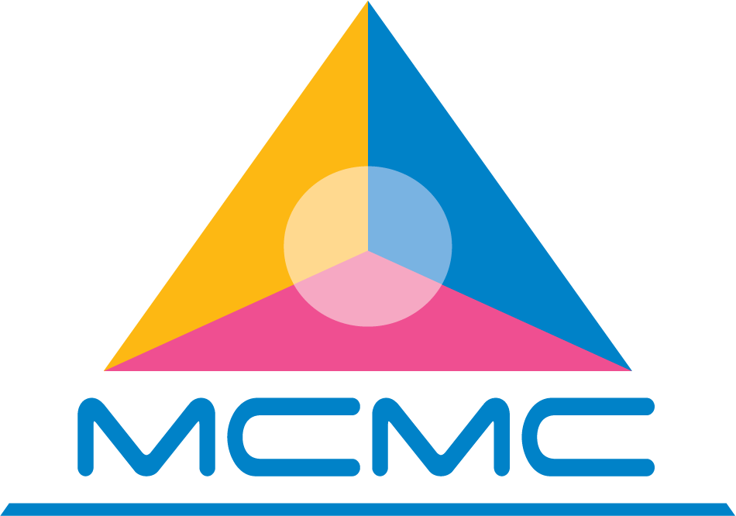
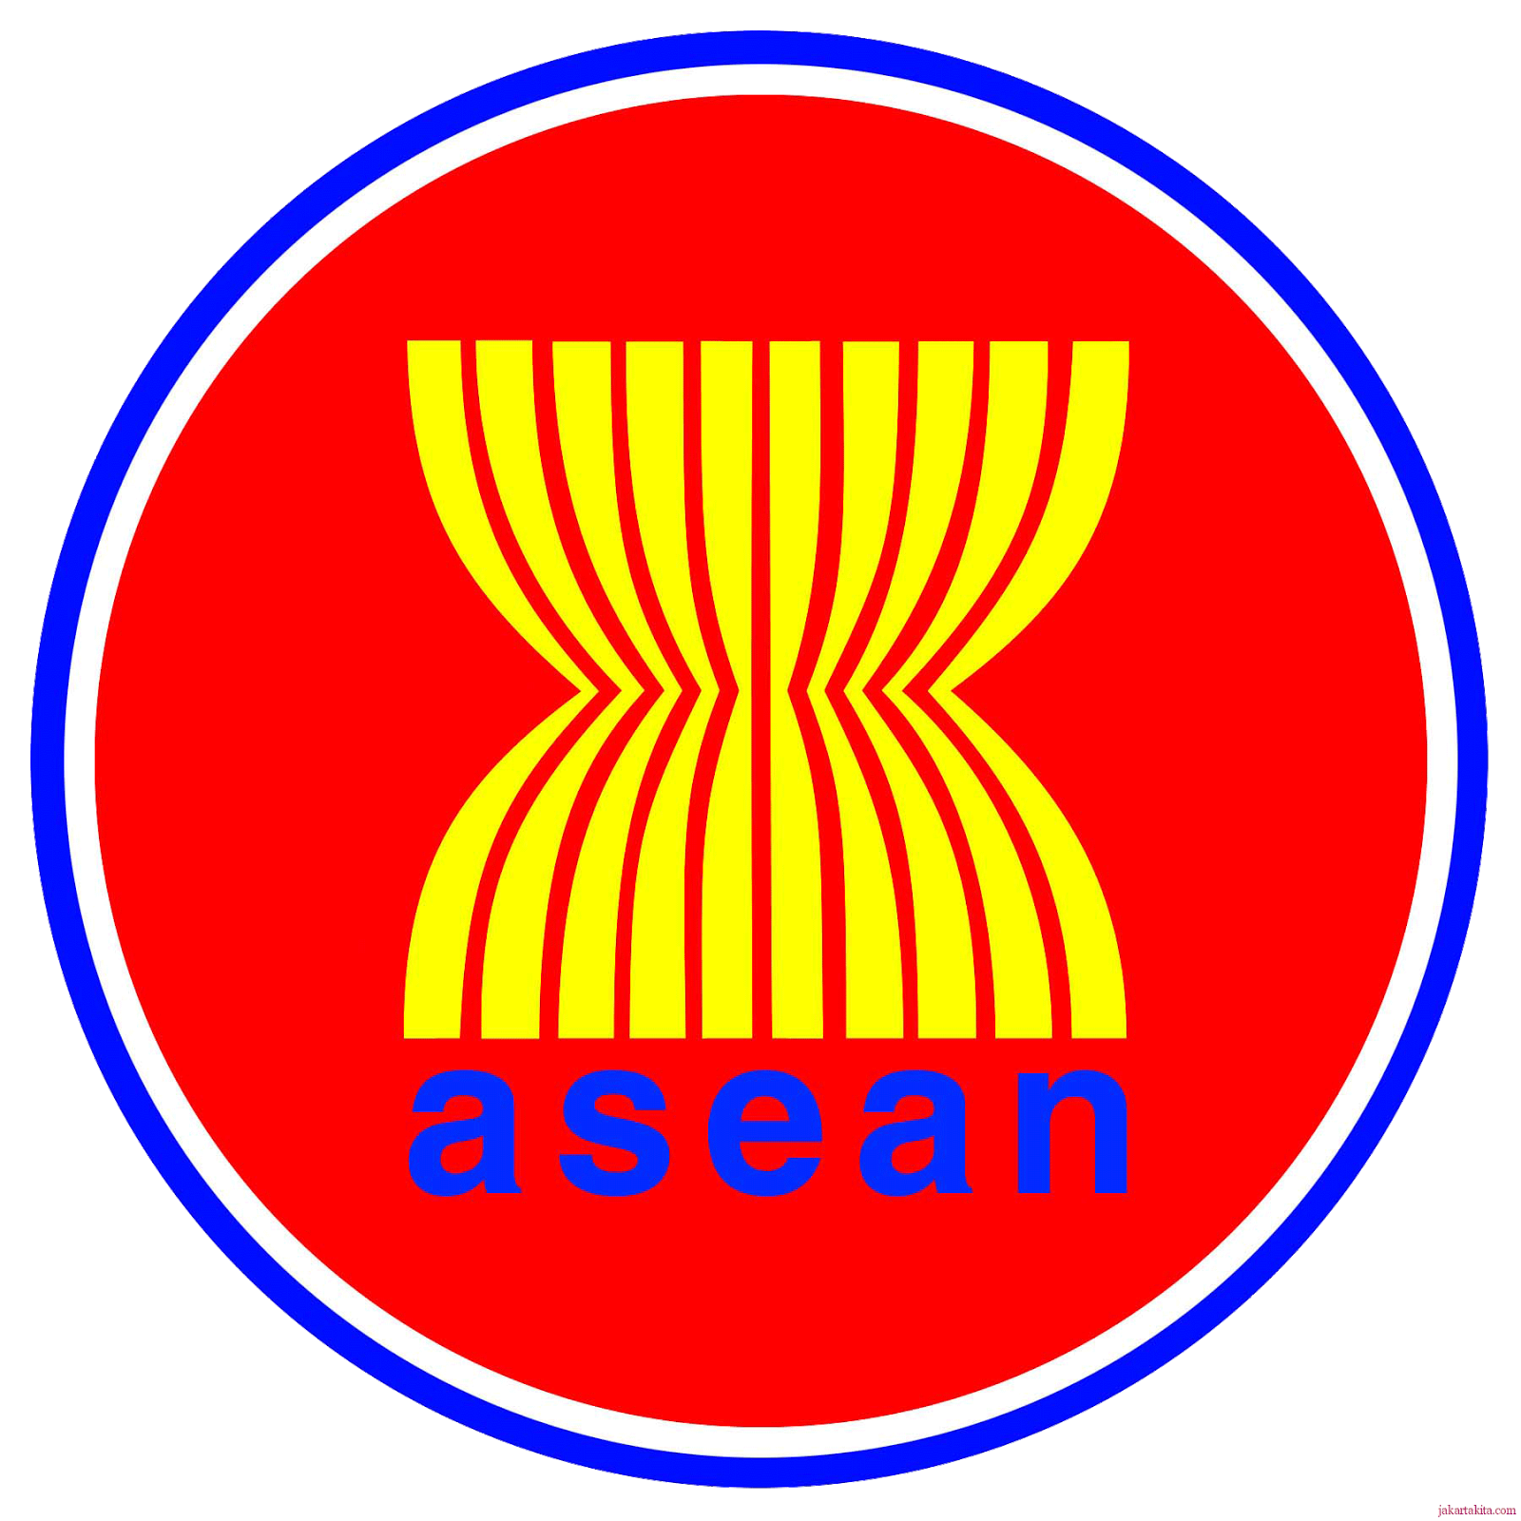
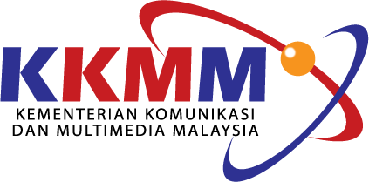

ITU - ASEAN Forum on Social Media: Trends, Opportunities, Policy and Regulatory Challenges

16-17 December 2014
The ASEAN Secretariat Building
Jakarta, Indonesia

Draft Agenda

16 December 2014 (Day 1)
08:30-09:00 | REGISTRATION
09:00-09:15 | Opening Session  - International Telecommunication Union  - Malaysian Communications and Multimedia Commission  - Ministry of Communications and Multimedia, Malaysia
09:15-09:30 | Group Photo and COFFEE BREAK
09:30-11:00 | Session 1: Promoting confidence, safety and positive use of social media  Topics:  - General Tools and Strategies  - Online Ethics: Delivering the right message to the right people at the right time in the right way
11:00-12:30 | Session 2: Confronting the social media regulatory challenge  Topics:  - Changing mandates of ICT regulators to address the challenges posed by social media  - The 4th Generation Regulator  - Self-regulation, co-regulation, cross sector regulation: Modes and Models
12:30-14:00 | LUNCH BREAK
14:00-15:30 | Session 3: Draft ITU Report on national policy and practices in public sector utilization of social media  Speaker: Mr. Alan G. Alegre  Break-out discussions on the findings and recommendations from the Report
15:30-15:45 | COFFEE BREAK
15:45-17:00 | Session 3: Draft ITU Report on national policy and practices in public sector social media utilization (Con’t)  Topics:  - Presentation of outcomes of the breakout session  - Possible policy framework in social media utilization by public administrations in ASEAN countries?
17 December 2014 (Day 2)
09:00-10:30 | Session 4: The telecommunication/ICT poliy makers’ and regulators’s perspectives of Social Media  Topics:  - Understanding the social media landscape for policy purposes  - Role of social media within the regulatory environment  - Legal and policy issues raised by social media
10:30-10:45 | COFFEE BREAK
10:45-12:00 | Session 5: Impact of Social Media on public sector organizations  Topics:  - How can government take advantage of the social media to engage citizens?  - Policy/legislative frameworks and institutions set up  - Overcoming internal and external barriers
12:00-13:30 | LUNCH BREAK
13:30-15:00 | Session 6: Current policies, practices and promotion on social media in Industry and Regional/International Organizations  Topics:  - Country Presentation  - Industry Presentation  - Regional/International Organization Presentation
15:00-15:15 | COFFEE BREAK
15:15-16:15 | Session 7: Panel Discussion: ASEAN Policy Framework on public sector social media utilization: Moving Forward
16:15-16:30 | Closing Session

