 | 1st ITU Asia-Pacific Centres of Excellence Steering Committee Meeting  16-17 February 2015  BANGKOK, THAILAND | 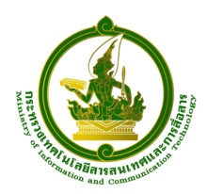

Registration Form

Please use CAPITAL letters
Family Name:……………………………………….………. Given Name:…………………………….…………..…………
Male: | Female:
Title/Designation:………………………………………………………………………………………………………………………
Name of Organization/Company:…………………………………………………………………………………..………..
Office Address:……………………………………………………………………………………………………………………………
Town:……… ………………………………………………. Country:…………………………………………………………………
Telephone Number(s):..…………………….…………………... Fax Number(s):……………..…….…………………
E-mail:……………………………………………………………………………………………………………………

Please fax/e-mail this form duly completed by 20 January 2015 at the latest to the following officers:
Contact ITU Regional Office:  Ms. Porntip Modethes  ITU Regional Office for Asia Pacific  Bangkok, Thailand  Tel. +66 2 575 0055  Fax +66 2 575 3507  E-mail: porntip.modethes@itu.int  cc: ashish.narayan@itu.int | Contact details MICT, Thailand:  Mrs. Sudaporn Vimolseth  TOT Academy  Nonthaburi,Thailand  Tel: +66 2 580 1076  Fax: +66 2 591 8087  E-mail: sudaporv@tot.co.th

