 | 1st ITU Asia-Pacific Centres of Excellence Steering Committee Meeting  16-17 February 2015  BANGKOK, THAILAND | 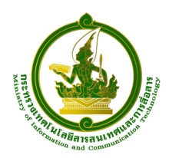

Useful Information for Participants
1. Training workshop venue
TOT Academy, TOT Public Company Limited, Nonthaburi 11000, Thailand
Tel: +66 25801076
Fax +66 25918087
E-mail: sudaporv@tot.co.th, thalimne@tot.co.th
At the TOT Academy, internet services are available at the training venue and the hotel.
2. Transportation
All participants are requested to make their own arrangements for airport transfer. More detailed information about the airport can be found on the following website.
http://www.suvarnabhumiairport.com/
After passing the immigration, an airport limousine can be hired from the counter by showing the TOT Academy map.
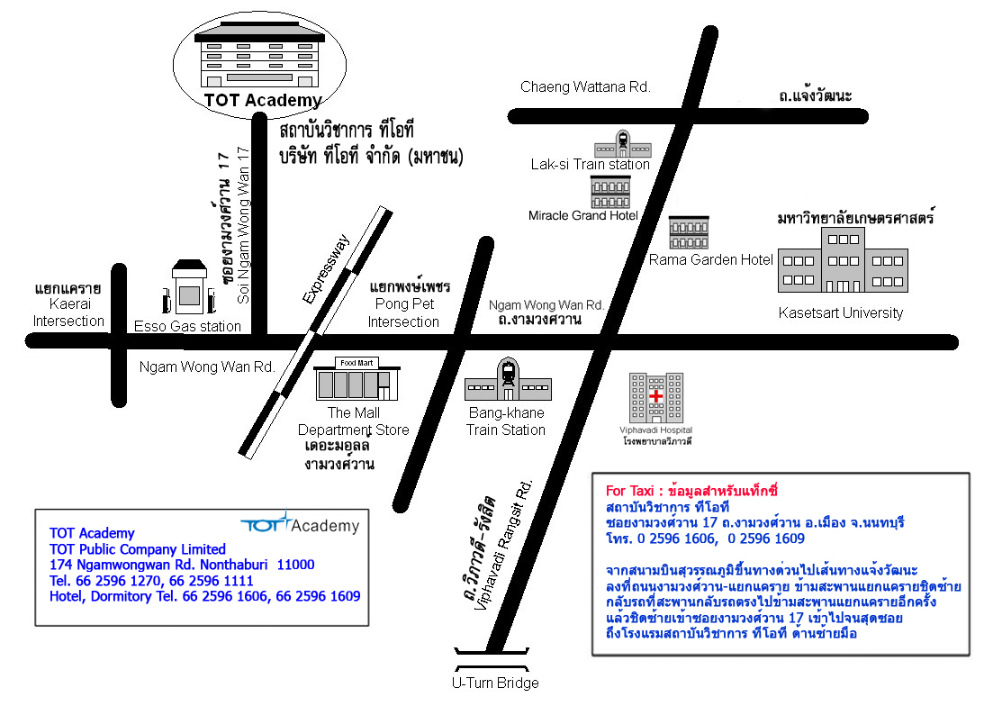

3. Passport and Visa
All participants entering Thailand must possess valid passports or accepted travel documents and need to check visa requirements before entering the country. Please check the visa requirement with the nearest Thai Embassy. For more information please visit the website http://www.mfa.go.th.
4. Contact point
For any further information you may require or if you need a personal invitation letter or official document for your visa application, please contact:
Mrs. Sudaporn Vimolseth
Tel: +66 2580 1076, Fax: +66 2591 8087
Email: sudaporv@tot.co.th
Ms. Tharinee Limpibunterng
Tel: +66 2596 1009 Fax: +66 2591 8087
Email: thalimne@tot.co.th
5. Practical Information
Weather
In February, the temperature is between 28 -32ºC.
Language
English is spoken in most hotels, shops and restaurants as well as in major tourist destinations.
Time
The time in Bangkok is 7.00 ahead of Greenwich Mean Time (+7.00 GMT).
Electricity
The electric current is 220 volt AC throughout the country.
Power Plug
For Thailand, the picture/diagram shows the type of main power plug used in Thailand so participants can bring the right adaptor for their electrical appliances. This plug and receptacle are technically known as NEMA 5-15 (North American 15 A/125 V grounded).
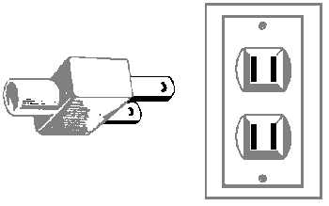
Currency
The currency exchange is 1$ USD is approximately 29 baht.
Business Hours
Government and business offices are open from 8.30 to 16:30 hrs, Monday to Friday. Bank opens Monday to Friday from 9.00-15.30 hrs while the department stores open daily from 10.00-20.00 hrs.
Local Travel during your stay
Participants staying at TOT Academy Hotel do not need to travel as training venue is co-located. For participants who would like to go out at night for their dinner or shopping, taxis can be called from the hotel or you can walk out to the main road and call a taxi. There are two shopping Malls, Supermarket and Food Court near the training venue.

Have a nice trip to Bangkok

