|  |  |  |
| --- | --- | --- |
| sigleITU |  |  |

**Annex 3**

ITU Asia-Pacific Centre of Excellence Programme

**“Wireless Broadband Roadmap Development”**

06-09 August 2016

Tehran, Islamic Republic of Iran

1. **Introduction**

The ITU Asia-Pacific CoE Program on **“Wireless Broadband Roadmap Development”** will be held in **Tehran, Islamic Republic of Iran** from **06-09 August 2016**. This program is organized jointly by the International Telecommunication Union, the Ministry of ICT (I.R. Iran) - ICT Faculty and the ALTTC. The training will be delivered in English.

1. **Venue of the Training**

Shariati St., Sh.Ghandi Conference Hall, ICT Ministry, Tehran, Islamic Republic of Iran

1. **Coordinators**

|  |  |
| --- | --- |
| **HOST COORDINATOR**  Mr. Hasan Pashaeizad  Ministry of ICT (I.R. Iran) - ICT Faculty  Telefax: +98 21 44658745  E-mail: [pashaey@gmail.com](mailto:pashaey@gmail.com) ;  pashaei@ictfaculty.ir | **ITU COORDINATOR**  Mr. Ashish Narayan  ITU Regional Office for Asia Pacific Bangkok, Thailand  Tel. +66 2 575 0055  Fax +66 2 575 3507  E-mail: [ashish.narayan@itu.int](mailto:ashish.narayan@itu.int) |

1. **ON-SITE REGISTRATION AND Working Hours**

* Venue : ICT Ministry, Tehran, Islamic Republic of Iran, Shariati st., Sh.Ghandi Conference Hall
* Date : 06-09 August 2016; Time : 0800 AM Onwards

1. **Visa Formalities**

All participants entering Islamic Republic of Iran must possess valid passports (6-month validation) or accepted travel documents and need to check visa requirements before entering the country. Please check the visa with the nearest I.R. Iran Embassy. For more information please visit the website: <http://en.mfa.ir>

**Note:** For the visa and invitation arrangements please send a copy of your passport as well as completed registration form to Iran coordinator at below email l:[**pashaey@gmail.com**](mailto:pashaey@gmail.com)

1. **ACCOMMODATION**

Participants can book the proposed hotel through the reservation website: <http://en.hotelyar.com/city/11/tehran-hotels>. If you need any more information please don’t hesitate to contact with Mr. Pashaei at pashaey@gmail.com

1. **LIST OF PROPOSED HOTELS**

The list of recommended hotels that are situated near the training is as follows:

***Persian Azadi Hotel: http://www.azaditehran.pih.ir***

Persian Azadi is an elegant 5-star hotel and located in northern Tehran, **approximately 20 minutes by car to the training venue** or just half an hour drive from the city centre through express way.

***Parsian Esteghlal International Hotel: http://esteghlalhotel.ir***

Parsian Esteghlal International Hotelis located on crossroad of Chamran and Valiasr st., Tehran. It takes approximately 25 minutes by car to the training venue.

***Espinas Persian Gulf Hotel:*** ***http://espinashotels.com***

Espinas Persian Gulf Hotel is located on Keshavarz Blvd., Tehran. Espinas Persian Gulf is a comfortable 4-star property located at the centre of Tehran. All its 202 rooms, with luxurious interiors, large bathrooms and 23 spacious suites.

***Tehran Grand Hotel: http://www.tehrangrandhotel.com***

With a privileged location, Tehran grand hotel is located conveniently in the heart of the capital city. The hotel is perfect starting points for trips to most of the business and shopping districts, 45 minutes from Imam Khomeini (IKA) International Airport, 20 minutes from Mehrabad domestic airport and **just 15 minutes to** **the training venue**. The hotel has Wireless Lan internet access.

This information will be updated further on the event website. Please check with organizers.

1. **DETAILS OF ARRIVAL AND TRANSPORT**

Participants are recommended to arrive at Imam Khomeini International Airport (IKA), which is located 45 kilometers from the center of Tehran. More detailed information can be found on the following web site [http://ikia.airport.ir](http://www.suvarnabhumiairport.com/) . For your arrival at Imam Khomeini International Airport, **airport taxis and public taxis** can be easily found from point of entry to hotels. Airport taxis will cost more than public one.

Local transportation from some hotels (to be notified) to the venue will be provided by the host. Please contact Mr. Mr. Hasan Pashaeizad for further details.**All participants are requested to make their own travel arrangements** from airport.

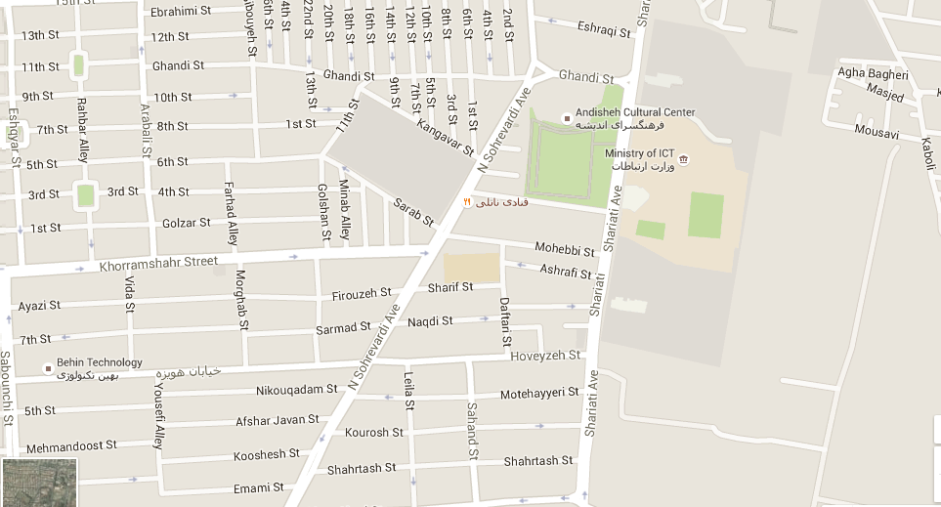

1. **CURRENCY**

The currency exchange for Iranian Rial to 1$ USD is currently approximately: 1$=33000 Rials. Government and business offices are open from 8.00 to 16:30 hrs, Saturday to Wednesday. Bank opens Saturday to Thursday from 8.00-15 hrs while the department stores open daily from 10.00-20.00 hrs. As international credit cards are not accepted, all participants are requested to make payments in cash.

1. **ELECTRICAL APPLIANCES**

The electric current is 220 volt AC throughout the country. The picture shows the type of main power plug used in Tehran so participants can bring the right adaptor for their electrical appliances. This two-wire plug is ungrounded and has two round prongs. It is popularly known as the Europlug which is described in CEE 7/16.

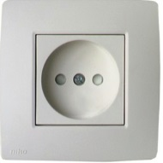 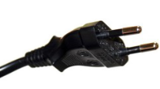

1. **LANGUAGES**

English is spoken in most hotels, shops and restaurants as well as in major tourist destinations and Persian is the country formal language.

1. **SECURITY**

It is safe in Tehran but however to travel at night time alone is sometimes not recommended.

1. **MEDICAL AND HEALTH**

All participants are requested to ensure medical and travel insurance covering the whole period of the training course and overseas travel. Neither ITU nor the ICT Ministry will be able to meet any expenses relating to injury, accident or medical treatment of the participant.

Drinking water from the tap is NOT recommended even though it is clean.

1. **WEATHER**

The time in Tehran is 4.5 hours ahead of Greenwich Mean Time (+4.5.00 GMT). **In August**, the temperature is between 28 -35 degree Centigrade.

1. **INTERNET**

Internet Access will be provided during training. For staying in the hotel, please contact the reception desk for access.

**Have a safe trip**

|  |  |  |
| --- | --- | --- |
| sigleITU |  |  |

ITU Asia-Pacific Centre of Excellence Programme

**“Wireless Broadband Roadmap Development”**

06-09 August 2016

Tehran, Islamic Republic of Iran

**Accommodation Reservation Form**

First Name:…………………………………………......…… Family Name:………………………..……………………….........

Organization name: …………………………………………………………………………………………………………………………

Country: ……………………………………………………………………………

Contact ddress: ……………………………………………………………………………………………………..……………………………

……………………………………………………..……………………………..……………………………..…………………………..…

Telephone No: …………………………………………….. Fax No: ……………………………..………..………

e-mail: ………………………………………………………………..…………..

|  |
| --- |
| **ACCOMMODATION DETAILS:**    **Hotel Name: …….........................................................**  Check-in date……………………………………………. Check-out date…………………………………….  Arrival Flight ….................................... ..Time...................................... |