Annex 2
ITU Centres of Excellence Network for Asia-Pacific Region

“Internet and IPv6 Infrastructure Security”
23-27 May 2016
TOT Academy
Nonthaburi, Thailand

INFORMATION NOTE
Supported by

- Introduction
The ITU Asia-Pacific CoE Programme on “Internet and IPv6 Infrastructure Security” will be held in Nonthaburi, Thailand from 23-27 May 2016. This programme is organized jointly by the International Telecommunication Union and the Ministry of ICT, Thailand with support from APNIC as part of the Broadband Access programme under the auspices of the ITU Centres of Excellence for Asia-Pacific region. The training will be delivered in English.

- Venue of the Training
TOT Academy, Nonthaburi, Thailand

- Coordinators
INSTITUTE COORDINATOR  Mrs. Sudaporn Vimolseth  TOT Academy  Nonthaburi,Thailand  Tel: +66 2 580 1076  Fax: +66 2 591 8087  E-mail: sudaporv@tot.co.th | ITU COORDINATOR  Mr. Ashish Narayan  ITU Regional Office for Asia Pacific  Bangkok, Thailand  Tel. +66 2 575 0055  Fax +66 2 575 3507  E-mail: ashish.narayan@itu.int

- ON-SITE REGISTRATION AND Working Hours
- Venue : TOT Academy, Nonthaburi,Thailand
- Date : 23May 2016 ; Time : 0800 AM Onwards

- Visa Formalities
All participants entering Thailand must possess valid passports or accepted travel documents and need to check visa requirements before entering the country. Please check the visa with the nearest Thai Embassy. For more information please visit the website http://www.mfa.go.th.

- ACCOMMODATION
Participants can book the proposed hotel through the organizer for special rate and confirm the availability or if preferred other hotel for their convenient. Please check the traffic to the training venue in the morning. Reservation form is attached at the end of this document.

- LIST OF PROPOSED HOTELS
The list of recommended hotels that are situated near the training is as follows:

Richmond Hotel
Richmond is an elegant 4-star convention venue and hotel located in northern Bangkok, approximately 15 minutes by car to the training venue or just half an hour drive from the city centre through express way. RICHMOND features 455 luxury rooms and suites. Pick up from the airport can be requested by paying for airport transfer.

TOT Academy
TOT Academy is located on NgamWong Wan Soi 17, Ngam Wong Wan Road, Nonthaburi, near the expressway from the airport to Chaeng Wattana and Bang Pra-in. The hotel is in the training venue just 1 minute walk to the training room. All 75 hotel rooms have good amenities ith complimentary wireless hi speed internet. For hotel guests, the hotel offers fitness and sauna. Three Shopping malls are located nearby, viz Pantip Plaza( IT Selling Center),
The Mall, Esplanade Shopping Center and Tesco Lotus Supermarket.

Mida Hotel
Mida Hotel Ngamwongwan is a comfortable 3-star property located 13.3km from the centre of Bangkok. Dining facilities at Mida Hotel Ngamwongwan include a restaurant. Breakfast is available.The hotel has a 24-hour front desk servicecomplimentary newspapers in lobby, concierge services, dry cleaning/laundry service, elevator/lift and roll-in shower. Mida Hotel Ngamwongwan offers transportation to/from the airport for an additional fee.

- DETAILS OF ARRIVAL AND TRANSPORT
Participants are recommended to arrive at Suvarnabhumi International Airport, which is located 45 kilometres from the centre of Bangkok. More detailed information can be found on the following web site http://www.suvarnabhumiairport.com/.For your arrival at Suvarnabhumi International airport, airport taxis and public taxis can be easily found from point of entry to hotels. Airport taxis will cost more than public one. All participants are requested to make their own travel arrangements from airport and place of stay (if different from the training venue) to the venue.
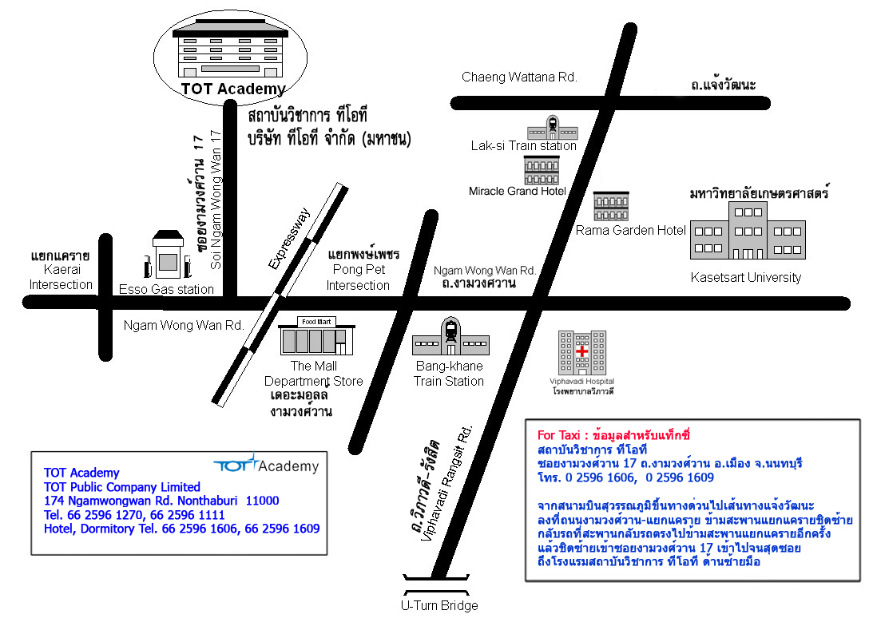

- CURRENCY
The currency exchange for Thai Baht to 1$ USD is currently approximately 33-35 baht. Government and business offices are open from 8.30 to 16:30 hrs, Monday to Friday. Bank opens Monday to Friday from 9.00-15.30 hrs while the department stores open daily from 10.00-20.00 hrs.
- ELECTRICAL APPLIANCES
The electric current is 220 volt AC throughout the country.The picture/diagram shows the type of main power plug used in Thailand so participants can bring the right adaptor for their electrical appliances. This plug and receptacle are technically known as NEMA 5-15 (North American 15 A/125 V grounded).
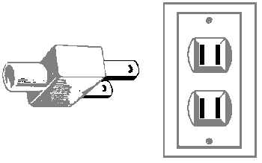
- LANGUAGES
English is spoken in most hotels, shops and restaurants as well as in major tourist destinations

- SECURITY
It is safe in Bangkok but however to travel at night time alone is sometimes not recommended.

- MEDICAL AND HEALTH
All participants are requested to ensure medical and travel insurance covering the whole period of the training course and overseas travel. Neither ITU nor the NBTC or MICT will be able to meet any expenses relating to injury, accident or medical treatment of the participant.
Drinking water from the tap is NOT recommended even though it is clean.

- WEATHER
The time in Bangkok is 7.00 ahead of Greenwich Mean Time (+7.00 GMT). In May, the temperature is between 28 -35 degree Centigrade.

- INTERNET
Internet Access will be provided during training. For staying in the hotel,please contact the reception desk for access.

Have a safe trip

ITU Centres of Excellence Network for Asia-Pacific Region
Face-to-Face Programme on
“Internet and IPv6 Infrastructure Security”
23-27 May 2016
TOT Academy
Nonthaburi, Thailand

Accommodation Reservation Form

First Name:……………………………………………………… Family Name:………………………..……………………….........

Company: ………………………………………………………………………………………………………………………………………………

Country: …………………………………………………………………………………………………………………………………………………
Contact Address: …………………………………………………………………………………………………..……………………………
……………………………………………………..……………………………..……………………………..……………………………..
Telephone No: ……………………………………….. Fax No: …………………………… e-mail: …………………………………..

ACCOMMODATION DETAILS
◎ Richmond Hotel
o Standard room 1,900 baht
o Deluxe room 2,500 baht
Check-in date…………………………………………….Check-out date…………………………………….
Arrival Flight ….............................. ..Time.............................

◎ TOT Academy Hotel
o Single room 1200 baht
o Double room 1500 baht
Check-in date……………………………………………Check-out date…………………………………..
Arrival Flight …................................Time.............................
http://www.totacademy.com

◎Mida Hotel (Ngarmwongwan Road)
( ) Standard and Deluxe room 1,800 baht
Check-in date…………………………………………….Check-out date…………………………………….

Remarks:Hotel rates per night are inclusive of service charge, VAT and American breakfast

Vegetarian meal: o YES o NO oDietary Preference: ...............................
Please send this form by e-mail to: ,sudaporvi@yahoo.com,natthaj@tot.co.th
or by fax to: +66-2591-8087

