 |  | 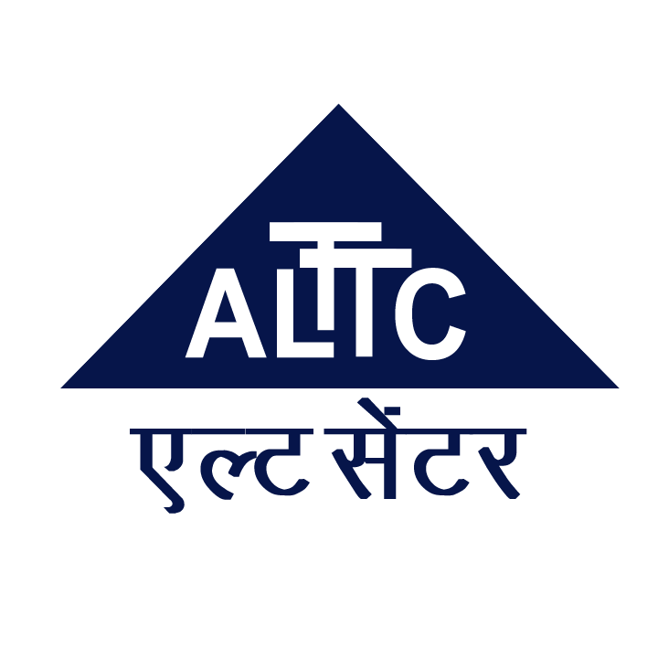

Annex 1
TRAINING OUTLINE

ITU Asia-Pacific Centre of Excellence Programme
“Wireless Broadband Roadmap Development”
06-09 August 2016
Tehran, Islamic Republic of Iran

COURSE DESCRIPTION

Title | Wireless Broadband Roadmap Development
Method of delivery | Face-to-face
Objectives | - To build knowledge of policy makers, regulators and telecom operators in the areas of wireless broadband ecosystem.  - To provide information on wireless broadband policy & regulation, standards and technology.  - To build skills on how to develop a roadmap for wireless broadband.
Dates | 06 – 09 August 2016
Duration | Four days
Registration deadline | 1 July 2016
Training fees | Free with support from Ministry of ICT (Iran) and ALTTC
Course code | 16DL17098ASP-E

LEARNING OUTCOMES

Upon completion of this training, participants will be able to

- Understand what are the key policies, regulations, spectrum, technologies and standards driving wireless broadband.
- Acquire skills for developing wireless broadband roadmap in the country.

TARGET POPULATION
Staff from policy makers, regulators, telecom operators, and academia responsible for wireless broadband.
FACILITATOR/EXPERTS

The experts for the training include experts invited by ITU, ALTTC and MICT (Iran). The details will be available at the course website.

EVALUATION
The assessment of the participants shall be based on the - time spent on the training and the following parameters:
Evaluation Parameter | Weightage ( in %)
Quizzes and presentations | 60 %
Attendance | 10 %
Participation | 30 %

The minimum passing requirement for certificate is 60%.

DRAFT TRAINING SCHEDULE AND CONTENTS / AGENDA
(Updated information will be available at http://www.itu.int/itu-d/asp)

DRAFT AGENDA
06 August 2016 (Day-1)
0800-0900 | REGISTRATION
0900-1030 | Opening Session:  Welcome Address  - ITU  - ALTTC  Opening Address  - MICT (I.R. Iran)  Group Photo
1030 – 1115 | Session 1: Where are we now: Wireless Broadband Ecosystem  Objective: To provide an overview of wireless broadband ecosystem including drivers, policy, regulations, business, technology others.
1115-1145 | Coffee Break
1145 – 1230 | Session 2: Wireless Broadband – Technology and Standards  Objective: To provide an overview of various technologies and standards driving wireless broadband including 3G, 4G and 5G (IMT 2000 and IMT 2020)
1230-14:00 | LUNCH
14:00-15:00 | Session 3: WRC-15 Outcome and update  Objective: To provide an understanding of WRC-15 outcome and update with special relevance to wireless broadband.
1500-1530 | Coffee Break
1530-1700 | Session 4: Working Group Exercise  Objective: To develop a national broadband wireless roadmap based on study undertaken by the ITU.
07 August 2016 (Day-2)
0930-1030 | Session 6: Spectrum Planning for Wireless Broadband  Objective: To recap fundamental technical information about spectrum engineering, spectrum forecasting and spectrum planning.
1030-1100 | COFEE BREAK
1100-1230 | Session 7: Spectrum forecasting – hands on exercise  Objective: To understand the technique for forecasting spectrum requirements using a working group exercise.
1230-1400 | LUNCH BREAK
1400-1530 | Session 8: Wireless Broadband Policy Case Studies  Objective: To share experiences on wireless broadband.
1530-1600 | COFEE BREAK
1600-1700 | Session 9: Wireless broadband – Network migration strategies  Objective: An overview of network migration strategies for wireless broadband services.
1700-1730 | QUIZ 1
08 August 2016 (Day-3)
0900-1030 | Session 10: Developing e-application strategies  Objective: To understand how countries can develop e-application strategies e.g. e-health, e-agriculture, which is critical for wireless broadband demand with case study?
1030-1100 | COFEE BREAK
1100-1230 | Session 11: Conformance and Interoperability of technologies  Objective: To look at some of the challenges that relate to conformation and interoperability of networks in broadband environment and how can the challenges be addressed.
1230-1400 | LUNCH BREAK
1400-1530 | Session 12: Working group exercise: Developing Wireless Broadband Roadmap  Objective: To develop a wireless broadband roadmap based as part of working group exercise.
1530-1600 | COFEE BREAK
1600-1700 | Session 13: Working group exercise: Developing Wireless Broadband Roadmap  Objective: To develop a wireless broadband roadmap based as part of working group exercise
1700-1730 | QUIZ 2
09 August 2016 (Day-4)
0900-1130 | Session 14: Wireless Broadband roadmap – Working Group Presentations  Objective: To present the wireless broadband roadmap developed by working groups in Session 12 and Session 13.
1130-1200 | CLOSING
1200-1300 | LUNCH
1300-1800 | FIELD VISIT
METHODOLOGY
The face-to-face programs will include
  - Instructor-led presentations,
  - Case studies,
  - Group exercises

TRAINING COORDINATION
ITU coordinator:
Mr. Ashish Narayan,
Program Co-ordinator, ITU Regional Office for Asia & the Pacific, 5th Floor, Thailand Post Training Centre,111Moo3 Chaengwattana Road, Laksi, Bangkok 10210,Thailand
Tel: +66 257 500 55, FAX: +66 257 535 07
Email: ashish.narayan@itu.int

Faculty of ICT-Ministry of ICT, I.R. Iran coordinator:

Mr. Hassan Pashaeizad
Fax: +98 21 44658745
E-mail: pashaey@gmail.com; pashaei@ictfaculty.ir

REGISTRATION

Registration for this program should be made by completing the attached registration form (Annex 2)

