 | ITU Regional Workshop on “Prospects of Smart Water Management (SWM) in Arab Region”  and  ITU Regional Forum on Internet of Things (IoT) for development of Smart Sustainable Cities (SSC) for Arab Region  Khartoum - Sudan, 12-14 December 2017 | 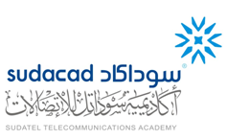

HOTEL RESERVATION FORM
(to be submitted before 1 December 2017)
(USE CAPITAL LETTERS)
1. Mr. / Mrs.
(Family name) (First name)
2. Country :

3.Address :

4. Tel.:__________________ Fax: __________________ E-mail :

5. Specify name of hotel ______
Hotel Fax No.______
Booking of a single room
Booking of a double room
from to
for nights

6. Arrival Date :
Day: _____________ Time : _________________ Flight No. : ________________
7.Departure date :
Day : ____________ Time : _________________ Flight No. : _______________

Date : Signature :

To be returned before 01/12/2017, to:  cc: | the hotel choosen  Eng. Atif Hamad Abdalla Hamad  Senior Manager, Planning and Development Dept., SUDACAD - Sudan  Tel: +249 183 467717  Mobile: +249 120120187  Fax: +249 183 487899  E-mail: atifha@sudatel.sd

